Ruby on Rails 5: Essential Training
What is Ruby on Rails

Introducing Ruby on Rails
Ruby on Rails is made up of two parts. Ruby and Rails.
Ruby is an object-oriented programming language created in 1995 by Yukihiro Matsumoto. Ruby can be used for many purposes, not just for web applications, it's just a general programming language. It's object oriented, it's easily readable, and it has an unsurprising syntax and behavior. It's easy to write code and it avoids some of the headaches in other languages, such as ending every line with a semi-colon.

Ruby on Rails is an open-source web application framework, which is written in the Ruby language. It is a framework - generally follows a basic software design principle of don't repeat yourself, or DRY for short.
The code is pre-configured to use default options which are going to fit the most common usages. This is going to speed up development and give us less code to maintain. Most of the time we can use the default settings, and we only needed to add code when we have use cases that are different. The defaults also follow best practices of web application development. So best practices will be built-in and improve our end product. Rails is very opinionated about what those best practices are. Most of the time, they're not controversial, but every now and then you may disagree with one of its default choices. The Rails framework also has many default features built in, especially web security features. Many of them happen automatically and you may never even notice them. Other features are not automatic, but are available if you ever decide that you need them. Working with a framework can pay big dividends as your web application matures and grows.

Understanding MVC Architecture
MVC is a fundamental aspect of rails, which is important to understand right from the start. M, V, and C. The 'M' stands for Model, the 'V' stands for View, and the 'C' stands for Controller.
The Model refers to the data objects that we use. It's the object oriented approach to design.
Many things can be objects in our models but the data in our Database will be the most common type of object that we'll put there.
The View is the presentation layer. It's what the user sees and interacts with. The web pages, the HTML, the CSS, the JavaScript. The Controller processes and responds to user events. Such as clicking on links and submitting forms.
The Controller makes decisions based on the request and then controls what happens in response. It controls the interaction with our Models and our Views.
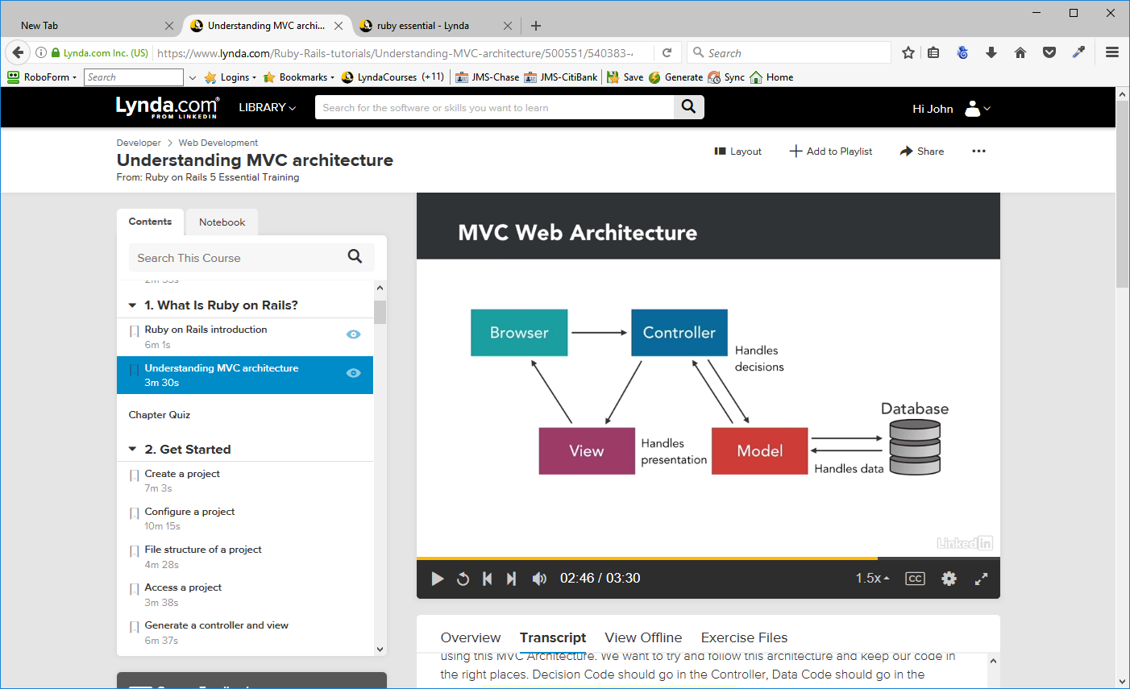

Rails actually has names for the code libraries it uses for these three parts. It calls the Controller "ActionController", and the View is "ActionView". The Model is called "ActiveRecord". Rails also packages together ActionController and ActionView as something called "ActionPack".

Get Started
Create a Project
Navigate to the folder in which you are storing the project
c:\Users\JMS2\Documents\RubyProjects\sites\RubyonRails5Lessons

rails new <<project_name>>
rails new simple_cms -d mysql

Creates the project, creates all files and runs bundle install – install everything needed for the project. If you install any more ruby gems, you need to run bundle again

Configure a Project
The very first configuration that you should perform is you should set up your application to use the correct RubyGems that it needs. The file to use is Gemfile. This is where you configure the RubyGems your application needs, and, of course, the most important one being Rails, and telling it which version of Rails that it needs. If you want to add additional functionality to your application you would do it by defining new RubyGems here. And as soon as you've defined them, and you're ready to use them you must go over to the command line, and from the root of your project type
bundle install
and hit Return.
When we first created theRails application, Rails ran bundle install and it went out and it got the code it needed, got everything installed so that our application would be ready to go. If we make changes to this file, we must run it again. It needs to go through and sync things up and make sure that it's got all the parts that it needs to run. So we'll need to run bundle install anytime we make changes to Gemfile.

The second configuration is in the config directory, and there are a few key files here that matter more than others. The first we want to call out is the application.rb file. This is our General Application Configuration. Configurations which apply to the application throughout.
There's another directory here called initializers and inside there are a bunch of .rb files. Anything in initializers will be run in initialzer application with the right configurations.
There's another directory here called environments and inside it are three different files development, production, and test. And those are the three default environments that Ruby on Rails gives you,

Finally, there's really only one thing that we have to configure in order to get our Rails application off the ground, and that is the database. We need to have a Rails database set up and configured so that our Rails application can find it even though it doesn't have any data in it yet.

create database simple_cms_development;
create database simple_cms_development;

grant all privileges on simple_cms_development.* to 'rails_user'@'localhost' identified by 'jms3172';
grant all privileges on simple_cms_development.* to 'rails_user'@'localhost' identified by 'jms3172';

Set up database.yml for the user and password entered above.

rails db:schema:dump
This will create the schems.rb file in the project – it will be empty but the fact that it can be created indicates that there is a connection to the database.

File Structure of a Project
Certain files are in the projec in order to make Ruby run properly. However there are others that are important to undertsnsd.

app directory

This is where most of the application code is inside, that there's a number of other directories. The most important ones are the models, the views and the controllers. You're going to put most of your code in those places.

helpers. These are really view helpers, they help us to write code in our views.
assets, is going to be the place where we're going to put our JavaScript, our stylesheets and some of our fundamental images that we're going to be using.
mailers – if you want your application send email, you could use for that.
jobs is for writing tasks that your application is going to do. Let's say, something it's going to do every night, at midnight. You could put a job in here for that.
channels is used for Action Cable. That's a new feature of Rails 5, and you would put all of your Action Cable code inside channels.

config directory.
This is where we're going to configure different aspects of our application. There are a lot of sensible defaults that are already in there, and we'll just need to override those and change them, whenever we want to make a configuration change.
db directory.
This is short for database and this is where all of our database files are going to go. Once we start talking about a database later, we'll talk about generating database migration files, and those would all live inside the db folder.
Gemfile.
This specifies what RubyGems our application is going to load up. You can see, for example, that it's going to load the gem for 'rails', version 5.0.0. Gemfile lock is related to the Gemfile but that's not a file we need to manage. Rails is going to handle that for us. We're going to add gems to the Gemfile, whenever we want to configure them.

log directory
That's where log files are going to be stored, as we work with our application. That's useful for tracking down errors and finding out what happened in an application.

public directory

This is where public files that don't need to be served up by the application can live.

test directory
If we wrote test code, using Test::Unit or Rspec, we could put that code inside the test directory

lib directory
vendor directory
These are other places to put code that might help you out. You typically want to put most of your application code inside the app directory. Most third-party code is now bundled up as a gem, so it will live in RubyGems, but if not, if you had some third-party Ruby code, you could put it in the vendor directory. Or, if you had code of your own that you wanted to reuse from project to project, you could put that in the lib directory. Most of the time though, you're going to want to put all of the application code in that app directory.

Access a project

The first step to doing that is that we need to start up a web server. We can use a very simple light-weight web server that's very fast, and that's what we're going to be using here. By default, Rails 5 is going to want us to use the Puma web server, so we don't need to do anything. That's already built-in.

rails server

This will start the Puma server and show us the port to which it is listening. Whenever we want to stop the web server, We just type CTRL + the letter C, and it will stop the web server for us.
If we want to restart the web server, we simply stop it and then start it again. Most of the time, you're not going to need to restart the web server. You can just leave it running, even if you're adding code to your application. The web server will pick up the latest code and serve those to you in your browser. However, there may be occasions where you feel like it's not giving you the latest code. This is most often true when you've made changes to configuration or initialization files. When this happens, just stop the web server and start it again so that you know you have a fresh copy running.
After our web server is running, then we can visit the site in a browser by going to http://localhost:3000

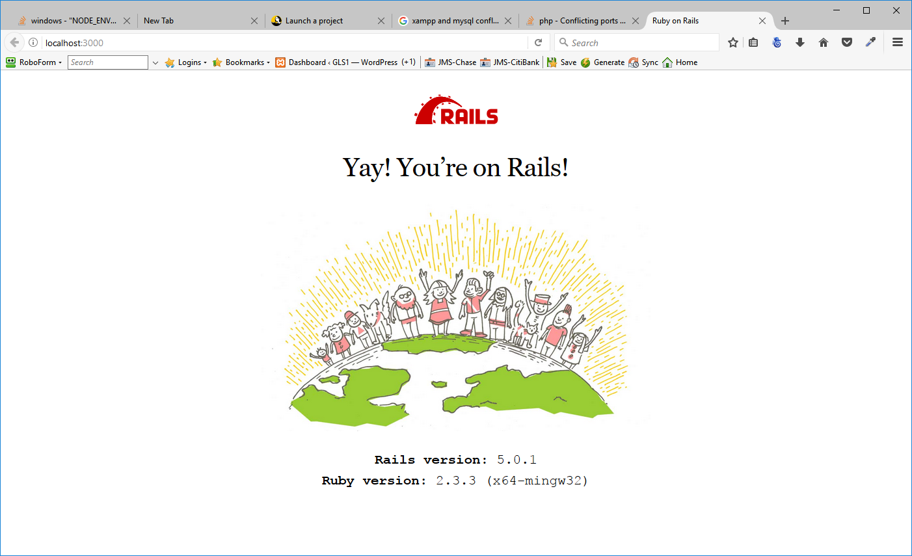

Generate a Controller and View
The browser and the controller and the view portion is the key triangle that must happen with each request. It's the minimum amount that a Rails application needs. The browser communicates with the controller, the controller goes to the view, the view goes back to the browser.

rails generate controller demo index
create app/controllers/demo_controller.rb
route get 'demo/index'
invoke erb
create app/views/demo
create app/views/demo/index.html.erb
invoke test_unit
create test/controllers/demo_controller_test.rb
invoke helper
create app/helpers/demo_helper.rb
invoke test_unit
invoke assets
invoke coffee
create app/assets/javascripts/demo.coffee
invoke scss
create app/assets/stylesheets/demo.scss

Controller Example
Set up the following files:
demo_controller_rb

demo_controller.rb
class DemoController < ApplicationController
layout false
def index
end
end

Index.html.erb

<h1>Hello, world!</h1>

Start the server
rails server
localhost:3000/demo/index will show the Hello World in the browser

Server Request Handling
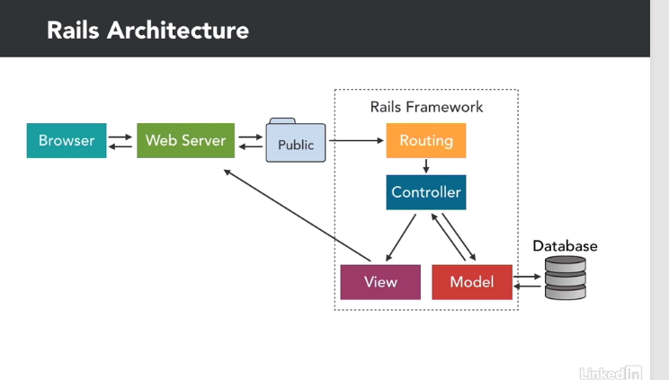

A request originates with the browser, it goes to the Web server (Puma) for processing.
The Web server is then going to look inside the project's public directory for a file whose path and name exactly match the browser's request. If it finds this file, it will return the file with the browser, and it will never access the Rails framework at all. This is useful because sometimes we want to return static HTML pages, images, stylesheets, JavaScript or other static assets that we want to return as quickly as possible, without going through the overhead of the Rails framework.
Whenever the Web server doesn't find a matching file, it's going to ask the Rails framework to handle the request. The request goes to Rails routing. Routing parses the URL, to determine which controller and action to use - in the section above we were working with demo and index. It will execute the controller action, and then it will make a request to the model as needed, and finally render our view, just like we saw with the regular MVC architecture. It returns that view back to the Web server, which then passes it back to the browser.
Two important points:
When you're configuring a production Web server, you will need to specify a document route. The document route is the public directory. Now, in development, Puma already knows that that's the document route, and uses it automatically, we don't have to specify it, but in production, you will need to configure your Web server to use that document route. As the name suggests, anything that goes in the public folder should be considered public, and that's true of most websites. What is different with Rails is that it tries to find a file in the public directory, and then if it can't find it, it asks the Rails application if it can handle the request.

Demonstration

- In public folder, add file static_page.html (from DL Lessons – 02-06).
Launch server – if not already running
rails server
- In browser - http://localhost:3000/static_page.html
The page will show – – This is a static page - note that the rails application did not do any processing of the request since it found it in the public folder
- Add new folder inside public – call it demo
- Move static_page.html into demo
- In browser – http://localhost:3000/demo/static_page.html – we get the same page – This is a static page
- In browser – http://localhost:3000/demo/index – we get the Hello, World page
This index page is actually in the folder \simple_cms\app\views\demo.
When Rails server cannot find a request, it will process it through the controller

Started GET "/demo/index.html" for ::1 at 2017-03-01 09:09:35 -0500
Processing by DemoController#index as HTML
Rendering demo/index.html.erb
Rendered demo/index.html.erb (0.0ms)

Most of the time you're not going to be putting static HTML files in your public directory. You really want to put all of your work inside the app directory, and let your Rails application serve it, but there are times where it is appropriate. For example, the 404, and 500 pages used to render errors are inside the public directory, as well as some of the images that we're going to be using we can put in our public directory, so that they can be served directly without having to go to through the Rails application.

Rails Routing
As we saw above, the Web server first looks for a matching file on the public directory, but can't find a match, it then sends the request to the routing portion of the Rails framework. Rails routing examines the URL, and from that, determines which controller and action should be called. It does this using route definitions in the application's routes file. There are several kinds of route definitions you can write. There's the simple route, also sometimes called the match route, the default route, and the root route.

In routes.rb we see the simple match route for the demo controller
get 'demo/index' – shorthand version
match “demo/index”, :to => “demo#index”, :via => :get
command match, and then the string, demo slash index. It's telling us that it's matching this string. Then, there's an argument to that, which is to, and it tells us where it's mapping it to. It's mapping it to the demo controller, and the index action. Notice the hash or pound sign separating those, demo, pound, index, (the controller and the action). Then, the last part is via get, and that's letting us know that it is matching it for a get request.

We always have to specify whether it's a get request, or a post request. If this had been a post request, it would not have matched. It only matches if the string is the same, and the request method is the same. If those two criteria are met, then it will route it to the demo controller, and the index action. While the longer version helps you to see what's going on, you can also see why people prefer that shorthand version, it's a lot less to type. If you were using only simple match routes, then it means that every single page in your application would have to have a static string associated with it, so it would know where to route it, and you could do it that way, but it's not very flexible.

Default route
It would be better if we could instead write a routing rule which would handle many cases that could parse the string into the right components, and that's what the default route allows us to do. The default route structure is controller, then a forward slash, then the action, and then a forward slash, and then the ID.
controller/:action/:id
GET /students/edit/52 will be routed to
students controller, the edit action and the student id of 52

Demo:
in routes.db – remove get 'demo/index' and you will get an error when you try to access http://localhost:3000/demo/index.html

Put in the line below and http://localhost:3000/demo/index.html will work
get ':controller(/:action(/:id))'

It took demo from the URL, it matched it according to that pattern that was in the routing rule, and it assigned to controller, and it took index, and it matched that, and assigned it to the action. If we take away index.html and hit return, it still returns the page. It is still able to route it, and that's because there's now a default value for action.
That default value is index. When we were using only the simple route, we had to have all of it. We had to have it explicitly match perfectly.

Note: Default routing may be removed from RubyonRails eventually – don't count on it.

Root Route
This is essentially the home page of your website. It's all well and good to match routes based on what comes after the domain name, but what do you want it to be if there is nothing to match at all? Where should that go? That's our root route. We could write that out in the long form by using match, but the shorter and better way that you will see most people do it is just to say root, and then a string telling it which controller and action should we route it to.
root 'demo#index' – Root Route
get 'demo/index' - Match Route

Note the difference – the # tells what controller to use while the / tells the server to try to match the file

Now http://localhost:3000 goes directly to the index page – not to the default Rails page

Practice

Generate a controller and a view

rails g –
will show the things rail can create for use – templates
Rails:
assets
channel
controller
generator
helper
integration_test
jbuilder
job
mailer
migration
model
resource
scaffold
scaffold_controller
task

Coffee:
coffee:assets

Js:
js:assets

TestUnit:
test_unit:generator
test_unit:plugin

rails generate controller march1 index2
Makes controller march1 and page index2.html.erb
Make change in routes.rb

root 'demo#index' – changed to get 'march1#index'

now localhost:3000 will bring up the index2 page of the march1 view
Therefore – the view folder is where you store your .html pages – see the diagram above

You can make up any page and make it the root by specifying it in the routes.db file
To add new pages to the project, you have to specify them in the roots.db file

Controller, Views and Dynamic Content
Render a Template

Create a new template under apps/view/demo – call it hello.html.erb
Create a route in routes.rb. Get 'demo/hello'

it is a good practice to have an action defined for each template. it serves to remind us that it is a possible choice that the controller can make without returning an error. The most common way to choose a template to render for an action is to let this default behavior kick in, to have nothing specified inside each action as to which template we're going to render. We just let the sensible default say, well, if it's the index action, then it must be the index template that we want to render.

However, if we don't want that default behavior, we can specify the template. And we do that by calling the render method and then telling Rails what template we want to render. We can do that in a few ways.
render(:template => 'demo/hello') - this tells the server what template to use (folder/name)
shorthand – render ('demo/hello') - It'll know that we're talking about a template cause that's mostly what we want to render.
Shorthand – render('hello') – we're already in the demo folder so n need to specify that

Add explicit render commands. In this example, we switch the actions from defaults to demonstrate the fact that the controller will look for the specified page in the action – it is not tied to the action but will follow the render command. The render command does not call the action specified, it just renders the page specified.

class DemoController < ApplicationController
layout false

def index #this is an action
#render('index') #the default action - does not need to be specified - overridden by the line below
render('hello') #sets the template for the index action to hello
end

def hello
#render('hello') #the default action - does not need to be specified - overridden by the line below
render('index') #sets the template for the hello action to index
end
end

In practice, render, when you explicitly render it, is most often used in conjunction with if-else statements. So, for example, if a user logs in successfully, then render a welcome page. If they did not log in successfully, then render the login form again. The important point is to understand the default behavior that's built into Rails and how to use render to override it.

Redirect Actions
The diagram that we've been looking at is deceptive because it appears that the controller's final step must be to render a view. But it can also make a different choice, and that is to perform a redirect instead. Redirects send a request to a different controller and action.
When you redirect, what actually happens is that Rails returns a status code to the browser which looks like this.

HTTP/1.1 302 Found
Location: http://localhost:3000/demo/hello

The location is the URL that we'd like to redirect the browser to. So when the browser gets that message back from the web server, it says, oh 302, you're trying to redirect me to a different page. The browser then immediately requests that new page, it's sort of a ping pong effect, we say we want you to redirect browser, and the browser says great, I agree to be redirected, give me that new page.

It is important to realize that it is actually a new request, we're going back to the browser, and the browser is making a brand new request to the web server which then goes back through the Rails routing into the controller and action. Any processing that took place during that first request is gone, if we made decisions, if it pulled any data out of the database or set any variables, all of that is going to be gone. We're going to need to pull that data back out of the database and get it ready a second time if we need to use it again.

Redirecting is also a different user experience than rendering. For one thing, the URL at the top of the browser will change when the user is redirected.

Creating a redirect
INnapp/controllers/demo_controller.rb
def other_hello
redirect_to(:action => 'index')
end
You also have to put get demo/other_hello in the routes.db file

Most of the time you're going to be redirecting to a different controller and action inside your own application. But it doesn't have to be, you can redirect to anywhere, including an external URL. For example, let's make another one here called lynda, and let's write a redirect that's going to go to http://lynda.com.

def lynda
redirect_to('http://lynda.com')
end
You also have to put get demo/lynda in the routes.db file

What's happening here is we are sending a message back to the browser saying hey, you need to make a new request to this new URL. That URL does not have to be back in our Rails application. When this second request happened to the lynda.com website, it never went through theRails application.
The first request did, we sent back a redirect, and then the second request just went to the lynda.com website. So a controller is able to render a template, or redirect, to a new location. And a redirect is actually just telling the browser that it should quickly go to a new URL.

View Templates
So far, view templates have been composed of only HTML, we could use just HTML, but that won't be dynamic or data-based driven. It would be much better if we could embed Ruby code into our templates so would could then put dynamic information into them. To do that, we're going to use ERB. ERB is short for "Embedded Ruby." It's an eRuby templating system to allow us to embed Ruby inside our HTML pages.

The file hello.html.erb means is we have a template named hello, we're going to process it with ERB, and when we're done, the final output format will be in HTML. There are other templating systems you can install and use instead of ERB, but ERB is the default one that comes with Rails. We can have different output formats, too, not just HTML. We can have XML, JSON, javascript or something else.

The first step in being able to embed Ruby code, is to make sure we have the correct file extension. If we don't have that .erb at the end, then Rails won't use ERB to process the file. The second step is to embed our code in the template. And we do that using ERB tags.

There are two versions of it. Each of them have <% and then our code, followed by %> at the end. Those are the bracketing tags that surround our code.
- the first one <% code %> does not have an = - it simply processes and executes Ruby code, the second will execute the Ruby code, then output whatever result that code returns into our template.
- the second one <%= code %> adds an = to it. It will execute the Ruby code, then output whatever result that code returns into our template.

So the first one does not output and the second one does .

<%= 1 + 1 %><br />
Will put 2 on the webpage

<% target = "world" %>
<%= "Hello #{target}" %>
Will print Hello world to the webpage

<%=
3.times do |n|
puts n
end
%>
Will not output to the webpage – will output 0, 1,2 to the console
Rendering demo/hello.html.erb
0
1
2
Rendered demo/hello.html.erb (1.0ms)

puts outputs to the console

To get webpage output
You have to break the commands into separate lines

<% 3.times do |n| %>
<%= n %><br />
<% end %>

will output 0,1,2 to the webpage

Instance Variables
How to use instance variables to give our templates access to data gathered by the controller.
The controller sets everything up ahead of time so the view can just focus on the presentation.
To pass data from the controller to the view we're going to use instance variables. Now just as a quick refresher remember that there are regular variables in Ruby and then there are instance variables. And the way we recognize instance variables is an instance variable always has an @ sign at the beginning. An instance variable is part of object oriented programming which says that this variable applies inside this instance of an object, that's its scope. In this case, the controller is the object because the controller is just a regular Ruby class.
Rails creates an instance of that class and then we can have instance variables inside of it. Then, when Rails uses ERB to render a template it matches the controller's instance variables with the instance variables used in the template. So the way we transfer data from the controller to the view is exclusively through these instance variables. That's the only way.

Example
in demo_controller.rb
add the line in the hello action
@array = [1,2,3,4,5] - Notice that we're using the instance variable with the @ sign, not a regular variable which is without the @ sign
When we render the template, the template's going to have access to values that are set with instance variables but if it was a regular variable it would not.

So, inside the view template, hello.html.erb where we have three times do, we change from the three times line to making an @array.each. Use the each method on that array which will render up each one of the elements in the array to the value n and then we can output that value.

<% @array.each do |n| %>
<%= n %> &nbsp;
<% end %>

This will produce 1 2 3 4 5 on the webpage

There's a close relationship between the controller and the view. In fact, their code is actually grouped together inside the Rails framework as part of action pack. Action controller and action view are both part of action pack. But even though they're related don't think that somehow you can go from the view back to the controller. It doesn't work that way. You can't go back and get something that you forgot. The controller has to set everything up ahead of time so that the view can present it and then send it back to the browser and move on.

Links
What we need now are the ability to create links we can put into our templates so that the user can click a link to initiate a new request.
It's uncommon to see plain HTML links written in Rails applications. That's because there's a helper method, which is easier to work with. In Rails, you would use the link to method. We're going to put that inside the ERB tags with the equals sign in front of it, because it's going to output an <a href> tag. The first argument to this method is going to be the link text and the second argument is going to be the link URL. The return value will be an HTML link.
The value of that target can be simply the string, like demo slash index, but it will also accept a Ruby hash, such as {controller => 'demo', :action => 'index'}. This makes it clear which controller and action we're using. And, if the link is to another action in the current controller, we can omit the controller part and just specify the action. We only need to specify the controller when we're changing to a different controller. Using this hash format to describe routes is a common technique in Ruby on Rails.

Demonstration:
index.html.erb -
<a href="/demo/hello">Hello page 1</a><br /> ---> plain HTML
<%= link_to('Hello page 2', {:action => 'hello'}) %><br /> ---> helper Method

Bring up the webapge and using developer tools, we see the output of the file is exactly the same – except for the labels - page 1,2

<a href="/demo/hello">Hello page 1</a><br />
<a href="/demo/hello">Hello page 2</a><br />
In hello.html.erb -
<%= link_to('Index page', {:action => 'index'}) %><br />

Now, opening the index file will have the two links to the hello file and they will both have the link back to the index page

Notice, that when we roll over the index page link on the hello page, it tells us that the path is going to be local host colon 3000. The path is not /demoindex because of our route definitions in routes.rb.
We have a root route that's defined as being demo/index and we also have another match route for demo/index. And Rails is going to prefer the shorter route. This is an important point because, it is important to realize that, when Rails uses that link to helper, it's actually using the route file (routes.rb) in order to figure out how to generate the URL.
Rails is referring to the route file not just when requests come in to the application to figure out where they should go, but it uses the route file also to figure out how to generate URLs so that they are appropriate for the application. So, it's going through and using these same routing rules in order to convert this hash into the correct URL. Using the link to helper makes it easy to put links onto our templates so that users can move around inside our application.

URL Parameters
What if we want to send other parameters in the URL string? Perhaps we're browsing a multi-page list, and we want to view only page five. We need a way for the URL to indicate that it's page five, and a way for the controller to be able to read that value in and use it. Remember that in HTML, URL parameters are the portion of the URL to the right of the question mark.

/demo/hello/1?page=3&name=kevin
In this case, page equals three, name equals Kevin. There are two additional parameters. They're key value pairs separated by an ampersand. That's just basic HTML.
The parameters object works a lot like a Ruby hash, but with a few special features. For one thing, it allows us to reference parameter values using either a symbol or a string. In normal Ruby, asking a hash for the symbol ID would return something different than asking for the string ID. But with parameters, we can specify keys using either symbols or strings.

In the line below, we add the page and id parameters to the link_to helper:
<%= link_to('Hello with parameters', {:action => 'hello', :page => 5, :id => 20}) %><br />

Looking a the page source in the browser we see:
<a href="/demo/hello?id=20&amp;page=5">Hello with parameters</a><br />

Go to routes.db and comment out the match routes leaving only the rout route root 'demo#index' and the default route get ':controller(/:action(/:id))'
Note that the id now has a special position inside the URL

<a href="/demo/hello/20?page=5">Hello with parameters</a><br />
However, we don't want to use the default route because Rails may stop supporting it.

Reset the route.rb file

Now that we've been able to successfully add parameters to our URL, let's try reading in those values. And the best place to do that is going to be inside our controller. Now you don't have to do it in the controller, params is still accessible in the view, but the controller is the best place most of the time. The controller is what makes choices, performs actions and remember, it's supposed to set everything up for the view to use.

Inside our hello action, so we read in those params values.
In demo_controller.rb
In the hello action add the lines:
@id = params['id']
@page = params[:page]

We're using a string and a symbol differently to illustrate the fact that they both work. In real life, as a matter of style, we might prefer one over the other, but, we have a choice, either one works the same.

Now that we're accessing these values, we're setting them to instance variables. Now they're available in our template, we go to the hello template and actually use those.

Add these lines to hello.html.erb
<br />

ID: <%= @id %><br />
ID: <%= params[:id] %><br />
Page: <%= @page %><br />
Next page: <%= @page.to_i + 1 %><br />

Now, opening the hello.html.erb page in the browser will show
ID: 20
ID: 20 – we have this here twice to demonstrate the different syntax for getting the params
Page: 5
indicating that it has received the data from the controller

Imagine that in addition to having the current page, we also wanted to list out the next page.
Add this line to hello.html.erb
Next page: <%= @page + 1 %><br />

We just do next page, page, plus one.
When we reload this page, we get an error back. And the error is a type error in Demo#hello. It tells us where the error was, and tells us that he problem is that there was no implicit conversion of fixed num into string.

The problem is that we're trying to add an integer, one, to the value of page, and page is a string.
And that's the important point, params are always strings. Ruby does not try and typecast this and try and guess that five should be an integer. Five will always still be a string. It's up to us to convert it into an integer if we want it to be.
To fix, we use the following line:
Next page: <%= @page.to_i + 1 %><br />
Adding the to_i method after page, it will convert the page number (5) into an integer. Now when we reload the file, we go back to the number six.

ID: 20
ID: 20
Page: 5
Next page: 6

So to recap, we were able to add parameters to our hash, the link_to method went to our routes file to find a matching route, and anything that wasn't explicitly declared in that route got added as a query parameter in our URL string. Then, in our controller, our controller has access to those values via params. We can then use those values and set the instance variables to make them available to our template.
When we come back to our template, we can output those values for the user to see, or we could also in our controller, use those values for something else. Perhaps if we had params ID, we would want to go to the database, and ask the database to return a record that had that ID.

Databases and Migrations
Introduction to Databases

Most models and rails will be connected to database tables. And in real world development, the process of creating those models usually begins by defining the database tables.

The schema is going to be the structural definition of a database. It defines the tables, the columns, the indexes, everything that makes up a database.

he database configuration is located in the config directory, in the database.yml file. Once you add the database name, the user, and the password to that file, Rails will then have access to the database.
A good way to confirm that Rails does have access is to dump the database schema file. And we saw how you could do that using rails db:schema:dump. Once we have a database created and configured, we're ready to tell Rails how to add tables to the database.

Migrations

We have created a database and configured our Rails project to connect to it. Next we need to add tables to that database and we're going to do that by writing Rails migrations. A migration is a set of database instructions. Those instructions are Ruby code, which migrates our database from one state into another. Essentially, they describe database changes. In our migrations we can create a table, add a column, change the name of a column, drop a table, and much more. A migration will contain both the instructions for moving to a new state and also instructions for moving back down to the previous state.
Migrations maintain our database schema with our application code.
Our application depends on having the database in a particular state and since they are closely coupled, we want to make sure that the description of the database is stored right alongside our application code. And because the instructions are written down, we can execute them anytime and they're repeatable.
If we take a project to a new computer and we want to recreate the database there, all we have to do is run our migrations and it'll put the new database in the same state. Another benefit of migrations, is that we can share database changes with other developers.

If there are two developers working on a project together and one developer adds a column to one of the tables and writes code that depends on that column, the other developer is going to need to add a column to their table to keep their code working. If they share the migration file, the developer can run the migrations and keep their databases in sync. Migrations also help with versioning. If you're using a version control system, like Git Or Subversion, you can check out a previous revision of the code and then migrate your database to put them in the same state the code expects.

Migrations also allow us to write Ruby code instead of writing SQL. You can still write SQL if you prefer, but Ruby gives us handy, easy to remember tools, that keep us from having to look up the SQL syntax. And using Ruby, migrations have easy access to our Rails application code.

Migrations are not a perfect solution. There can be issues with sharing schemas, with making changes to existing migrations, or with getting the database into a state where migrations won't run up or down until you go in and manually tinker with it. But developing using migrations is much better than developing without them.

Generate Migrations

rails generate migration DoNothingYet
invoke active_record
create db/migrate/20170303145305_do_nothing_yet.rb

Creates folder migrate under db folder and creates file 20170303145305_do_nothing_yet.rb
The timestamp is going to be useful for a few reasons. If we create two migrations with the same name, we probably didn't create them at the exact same second. That can be especially helpful when we're collaborating on our project with other developers and we might both be creating migrations. It makes each migration unique. The timestamp also puts our migrations in order, sorted by the time that they were created. We usually want to make changes to the database in a particular order.
Migrations also use this timestamp as an identifier. We're going to refer to a migration by its timestamp identifier, not by its name.

File Contents:
class DoNothingYet < ActiveRecord::Migration[5.0]
def change
end
end

Class inherits the Active Record property Migration
change is a method for moving in the database – shorthand for up and down methods
For learning, we change it to the up and down methods

class DoNothingYet < ActiveRecord::Migration[5.0]
def up
end

def down
end

end
Later when we run our migrations, Rails is going execute the code that's inside our up or our down methods. Up will describe the changes we want to make to the current database. Down will describe how to reverse those changes, to undo the code that's in the up method. They're going to be mirror images of each other. If the up method creates a new database table, then we would expect the down method would delete or drop that table.
The change method is a shorthand which allows us to write only the up code, and then let Rails try to reverse those actions. For example if we create a new database table, Rails is smart enough to realize that the reverse of creating a table is dropping that same table. Not all actions can be automatically reversed though. In which case, you can't use change. You would have to use these explicit up and down methods.

Generate Models
rails generate model User ==> Always use CamelCase when generating models
invoke active_record
create db/migrate/20170303150921_create_users.rb
create app/models/user.rb
invoke test_unit
create test/models/user_test.rb
create test/fixtures/users.yml

Rails created a migration for us, it gave it a timestamp that is different from the timestamp we used previously, and it named it for us, create underscore users. Notice that it's plural there.
You can see that it also created a new file for us, in app, models, user.RB, that's where we will put the definitions for a model later on, and it gave us some placeholder files in our test directory for testing the model.

Change the default to:
class CreateUsers < ActiveRecord::Migration[5.0]
def up
create_table :users do |t|

t.timestamps
end
end

def down
drop_table :users
end

end

The important thing to know is that inside the create_table code block is where we want to put our column definitions, and we don't have any yet. What it does is it yields up the table as the variable T, and then we apply columns to that table.
t.column "first_name", :string, :limit => 25
Now, with MySQL, string is going to translate to be a varchar column. If we were using a different database, then Rails would translate string into whatever type that database used. Migrations try to be database independent. We can write in the Rails migration code string, and Rails will take care of translating it to whatever the database needs. Also, there's a shorthand that you can use for writing out these column definitions as well. Instead of having to write column, since we know that pretty much everything we're going to do inside this code block is going to be add columns, we can just simply write T dot string, and then put the name of the column that we want.
t.string "last_name", :limit => 50

Final code:
def up
create_table :users do |t|
t.column "first_name", :string, :limit => 25
t.string "last_name", :limit => 50
t.string "email", :default => '', :null => false
t.string "password", :limit => 40
t.timestamps
end

Two special columns -
t.datetime "created_at"
t.datetime "updated_at"

If a column has one of those two names, then Rails is automatically going to populate and update them for us. It's very handy to have these two values on almost every single table. You'll know when a record was created, and you'll know when it was last updated, and you don't have to do any additional work, Rails is going to manage those values for you. Because they are used so often, they also have a shorthand, which is T. timestamps. Rails gives that to us by default, so we don't actually need these.

Almost every table that we create is going to have an ID, a unique, auto incrementing integer that identifies the record. It's also referred to as the primary key. Having an ID column as a primary keys on tables is so common that Rails will automatically add it for us. That's Rails's sensible defaults at work. We don't have to remember to add a column for ID, Rails will do it. In fact, we only need to specify when we don't want it to add an ID column. In that case, after create table, we would add an argument that says ID false, and that would turn off that behavior for us.

Run Migrations
Now that we've written the create users migration, we need to run the migrations in order for those changes to take effect on our database.

rails db:migrate
== 20170303145305 DoNothingYet: migrating =====================================
== 20170303145305 DoNothingYet: migrated (0.0000s) ============================

== 20170303150921 CreateUsers: migrating ======================================
-- create_table(:users)
-> 0.0095s
== 20170303150921 CreateUsers: migrated (0.0095s) =============================

This is the typical output that you'll see when a migration runs. You'll see that it tells us the time stamp and the name of the migration it's running. It will tell you that it's beginning the migration. It will tell you that it finished the migration. With DoNothingYet, it didn't do anything inside of there.
For create users, it said migrating, and then it told us that it was creating the table, users, and then it told us when it was done, and it also tells you how long the process took.

Notice that when we ran db:migrate, it ran both migrations. When we run db:migrate, by default it runs all migrations which have not yet been run.

To open database ===> from command prompt
mysql -u rails_user -p simple_cms_development
show tables;
show fields from users;
show fields from schema_migrations;
+---------+--------------+------+-----+---------+-------+
| Field | Type | Null | Key | Default | Extra |
+---------+--------------+------+-----+---------+-------+
| version | varchar(255) | NO | PRI | NULL | |
+---------+--------------+------+-----+---------+-------+
select * from schema_migrations;
+----------------+
| version |
+----------------+
| 20170303145305 |
| 20170303150921 |
+----------------+
Notice that it stored the two time stamps for the migrations that it just ran. This is how rails keeps track of which migrations have been run already, by adding an entry to this table. If we run seven migrations, and then we add another three migrations rails will know which three migrations need to be run, by comparing those file names, the identifier that's there, against the version number that's here.

Exit mysql
In the database, notice the schema.rb now has the time stamp of the last migration that was run and alos the definition of the table we created with that migration.
The schema file should always contain all of the definitions defining the current database in its current state, what it looks like and what are the steps that it would take to recreate that database.

To migrate back down

rails db:migrate VERSION=0
This will reverse any processes that have been run on the db, removing all tables, etc.
The schema.rb wil lonely have on line – version: 0

Finding status of migrations
rails db:migrate:status

database: simple_cms_development

Status Migration ID Migration Name
--------------------------------------------------
down 20170303145305 Do nothing yet
down 20170303150921 Create users

This will go in and have rails report to you which ones of the migrations have been run and which ones have not been run.
This is also a good way to get the ID numbers. You can copy and paste this ID number so we can have rials db:migrate specify the VERSION= and paste in the identifier. Now it runs all of the migrations to get up to that version. So, if we had 10 and we picked the fifth one, it would run the first five migrations. It doesn't just run that one migration only.

Migrate commands
rails db:migrate:up where you specify a particular version, in this case, it doesn't go to that version, it only runs the up method on that single migration,
rails db:migrate:down does the same thing, so you should always provide a version number when you're using up or down, because you're telling it specifically go run that migration's up or down method.
rails db:migrate:redo - redo is the same thing as doing down for that migration, and then doing the up again. By default, it uses the last version, so it can be helpful if you're only running one migration, you can just say redo and it will do a down and a quick back up again.

Migration Methods
Migrations allow us to perform mini-database operations.
Table Migration Methods
create_table (table, options) do |t|
drop_table (table)
rename_table(table, new_name)
Column Migration Methods
add_column(table, column, type, options)
remove_column(table, column)
rename_column(table, column, new_name)
change_column(table, column, type, options)
index migration methods
add_index(table, column, options)
We can make indexes across more than one column by passing in an array to column with all the column names in the array.
remove_index(table, column)

Practice
rails generate migration AlterUsers
Make changes from default
class AlterUsers < ActiveRecord::Migration[5.0]
def up
rename_table("users", "admin_users")
add_column("admin_users", "username", :string, :limit => 25, :after => "email")
change_column("admin_users", "email", :string, :limit => 100)
rename_column("admin_users", "password", "hashed_password")
puts "*** Adding an index ***"
add_index("admin_users", "username")
end

def down
remove_index("admin_users", "username")
rename_column("admin_users", "hashed_password", "password")
change_column("admin_users", "email", :string, :default => '', :null => false)
remove_column("admin_users", "username")
rename_table("admin_users", "users")
end
end

Notice that these are the mirror images of each other. Not only have we reversed each of the operations, but we've done it in the reverse order.

rails db:migrate
This will run only the migrations that have not yer been run – in this case alter_users – not that it only runs the add method

Check to see if the down methods work

rails db:migrate VERSION=0

Solving Migration Problems
Migrations make managing your database schema easy, however problems often occur when we're running our migrations and run into a bug in our migration code. It can leave your migrations in a broken state where you can't migrate up and you can't migrate down. It's important to learn how this happens and how to resolve these problems when they occur.
Demonstration: We to create a bug in my migration code.
Start by migrating down.
rails db:migrate VERSION=0

Then, in migration alter_user, change the man of the 'password' column to 'broken' in the rename_column line under add

rails db:migrate
First two migrations will run but the third (alter_user) will fail
rails aborted!
StandardError: An error has occurred, all later migrations canceled:

No such column: admin_users.broken

First two migrations ran successfully. We can see this by looking into mysql.
Also, it completed all the steps in the alter_users migration up to the area where it encountered an error.
We can see that the migration failed when we look at the migration status:
rails db:migrate:status

database: simple_cms_development

Status Migration ID Migration Name
--------------------------------------------------
up 20170303145305 Do nothing yet
up 20170303150921 Create users
down 20170303161821 Alter users

To fix:
Go back to migration alter_users and fix the line that caused the error

rails db:migrate
Another error – table admin_users already exists
rails db:migrate VERSION=0
We get another error. This time it had unknown table users for drop table users. It tried to run the create_user migration drop table user but it couldn't because that table doesn't exist anymore. We renamed it. So we're stuck in this state where we're in between the two migrations. We can neither go up or down. And fixing the bug in our code doesn't solve the fact that we're now in this in between migration state. So we're kind of boxed in. To resolve it we have to get our database to either the up state or the down state. We don't have any code to move it through half states.

One solution would be to open up mysql and to use mysql commands such as drop table and then edit the contents of schema migrations to match what's there and what's not there. That would work but we're not going to do it that way.

Instead we solve the problem just by editing our migration file. The problem is that we got halfway through this migration. The first three lines ran successfully. We can't run them again. So what do we need to do? We should comment them out by putting a pound sign in front of them. So all of those lines are now commented out so when we try to run this up migration now the first thing it's going to do is run the command
rename_column("admin_users", "password", "hashed_password")
which is the one we want it to start with.
rails db:migrate
Now the migrtaion alter_users will work

The best solution is to go into your migration file temporarily comment out the part that's giving you trouble so you can get the migration to either an up or a down state.

Change the alter_users migration back to its original state and run the migration down and up to make use that all is working OK.

It's good to keep your migrations small and concise. Don't overload them with too many changes or you'll create more of these kinds or problems for yourself. Instead break up each one of the migrations into small pieces. You can have several method calls in one migration. Especially if they're related changes. But for example you would never want to create four tables inside one migration. Have four different migrations for it. Finally make sure that all migrations are working 100% correctly in your development environment before you migrate to your production database.

Challenge:Migrations for the CMS

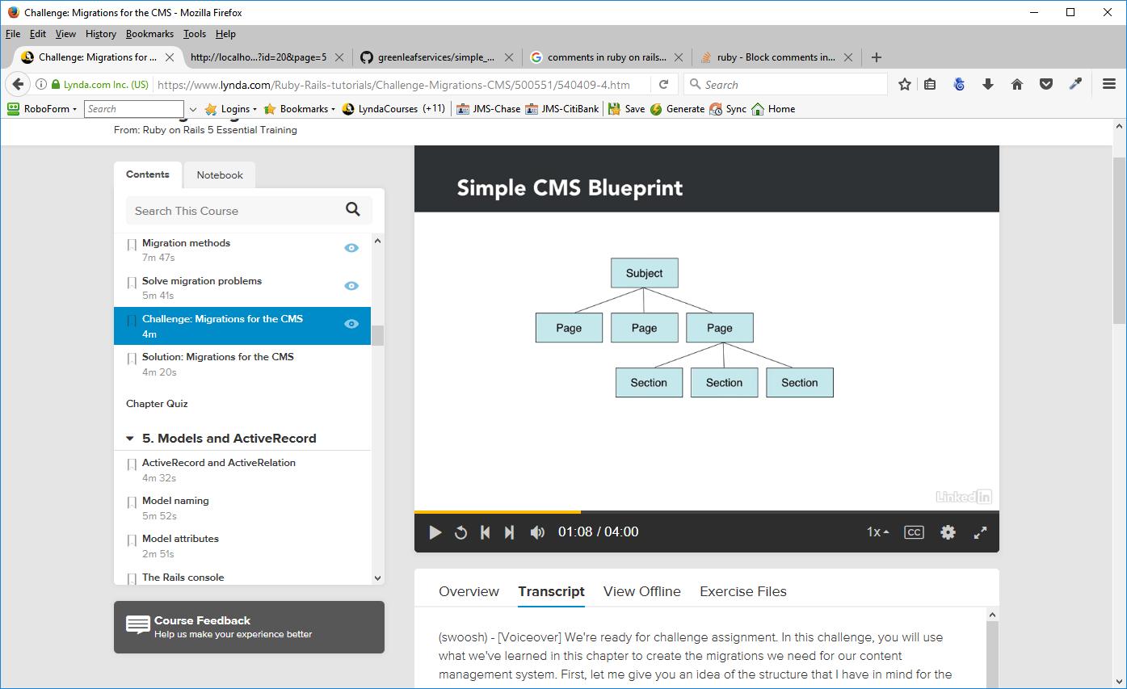
Create models and folders for the files above

rails generate model Subject
rails generate model Page
rails generate model Section

Note: generate model create the migrate and the model at the same time

Set up the tables inside each migration/model

def up
create_table :pages do |t|
t.integer "subject_id" # foreign key
t.string "name", :limit => 50
t.string "permalink"
t.integer "position"
t.boolean "visible", :default => false
t.timestamps
end
add_index("pages", "subject_id") #index to foreign table - table name and ID field
add_index("pages", "permalink")
end
def down
drop_table :pages
end

Note: In this instance, we changed the default change method to up and down and added commands in each method.
Also note the index lines – they are necessary, especially if we are tying this table to another (the line with subject_id tells mysql that we are linking to the subject able and the id field in that table – that is the convention for rails. We can make indexes across more than one column by passing in an array to column with all the column names in the array.

rails db:migrate
This will run any migrations not yet performed and create the tables

mysql showtables; ==> will show the tables in the database

Models and Active Record
Active Record and Active Relation
ActiveRecord (capital A and capital R) makes our objects intelligent. Our objects understand the structure of the database tables and knows how to interact with it. Our objects contain not only data but they also contain code for creating, reading, updating and deleting rows in the database. Therefore, these objects can be manipulated and saved back to the database with just a few simple commands.

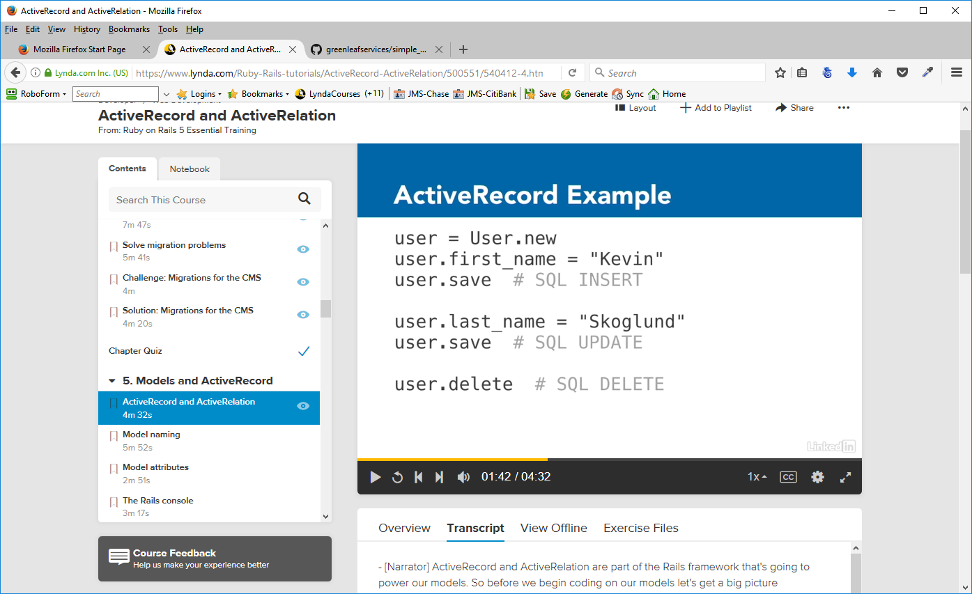
With the line user.save, ROR will write the mysql insert statement for us, no need to write out the sql code.
We can let our objects handle writing all the SQL statements that's needed to get the job done ==> intelligent objects.

ActiveRelation. It's also sometimes referred to as ARel short for ActiveRelation. ActiveRelation, is an object-oriented interpretation of relational algebra.
ActiveRelation simplifies the generation of complex database queries. It allows us to write small queries which can then be chained, one after another. Like most Ruby objects can. It takes care of handling complex joins and aggregations and makes sure that it uses efficient SQL to do it. It also manages the timing of when queries are executed. Queries don't execute until we actually need them.
ActiveRelation is going to be used heavily by ActiveRecord for queries, and for managing relationships between our objects.
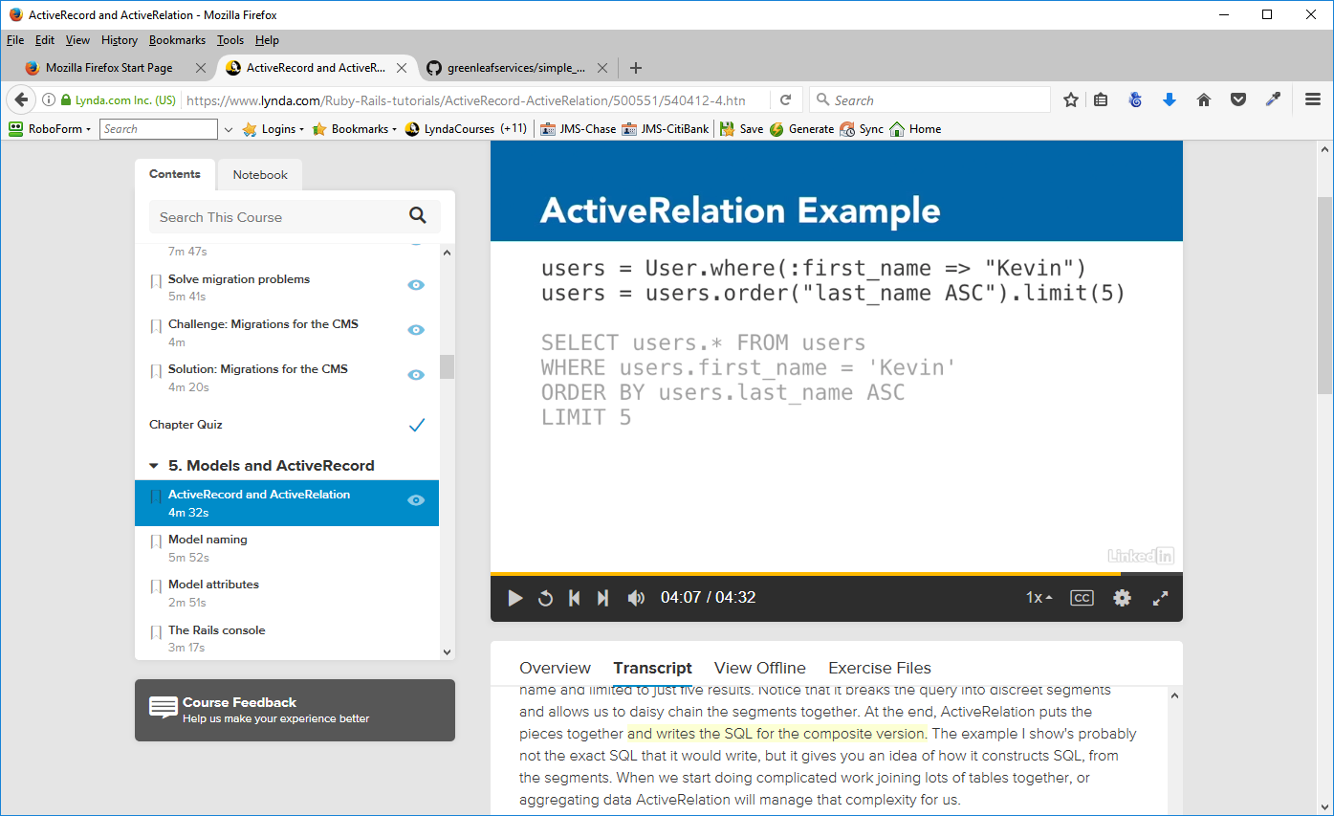
Here, we're finding all users where the first name is equal to Kevin.
In the second line, we're adding to that query. And the query should also be ordered by the last name and limited to just five results. Notice that it breaks the query into discreet segments and allows us to daisy chain the segments together. At the end, ActiveRelation puts the pieces together and writes the SQL for the composite version. When we start doing complicated work joining lots of tables together, or aggregating data ActiveRelation will manage that complexity for us.

Model Naming
Table names, file names, and class names matter a great deal in Rails. If we name things the way that Rails prefers, then Rails can use its sensible defaults to find files and code without us having to explicitly tell it where to find them. For example, if we write code that needs to use a model called Subject, then Rails will automatically look for a definition in the file, app/models/subject.RB. If our code asked that subject class to retrieve data from the database, then Rails defaults will tell it to look for a table called subjects, the down cased plural of the class name.
Your model files should always reside inside app, and inside the models directory. In there, you can see the different models we've created already, user.RB, subject.RB, page.RB, and section.RB.
Opening user.rb we notice that it has two lines:

class User < ApplicationRecord
end

This is a simple Ruby class, called user. It inherits from ApplicationRecord. ApplicationRecord Is actually just another file in the models directory. If we open that up, you will see that all it really does is inherit from ActiveRecord base.

class ApplicationRecord < ActiveRecord::Base
self.abstract_class = true
end

ApplicationRecord is going to be a place where we can put code that is common to all of our models. The important thing to know is this ActiveRecord base is the core part of Rails where we are adding behaviors to our class. User is able to do a lot of things using the ActiveRecord design pattern, by inheriting from ActiveRecord base.
The file name, user.RB, does match the class name in the file and that's important .

However, in our alter_users migration, we changed the name of the users table to admin_users. By doing that, we've now gone against Rails naming conventions. When our user class tries to work with the database, it's going to automatically look for a table called users, and it won't find one. Instead, we will get an error. We don't have to follow the Rails naming conventions, but if we stray from them, we do have to add configuration so it knows where to find things.

There are two possible solutions here. The first is that we can tell our class where it should find its table.

self.table_name = "admin_users"

This is especially useful if you have legacy databases that don't follow the Rails conventions. You want to use some simple sort of updated model names, but you want to use whatever the legacy database name is.

Another way, which is that we can change the class name to be AdminUser, but if we do that, we also have to rename the file ==> user.rb to admin_user.rb.

The names of files, classes, and tables are not an accident, and you need to stick with the Rails conventions, or else add your own configurations whenever you go against them.

Model Attributes
Addressing database table fields by ruby code:
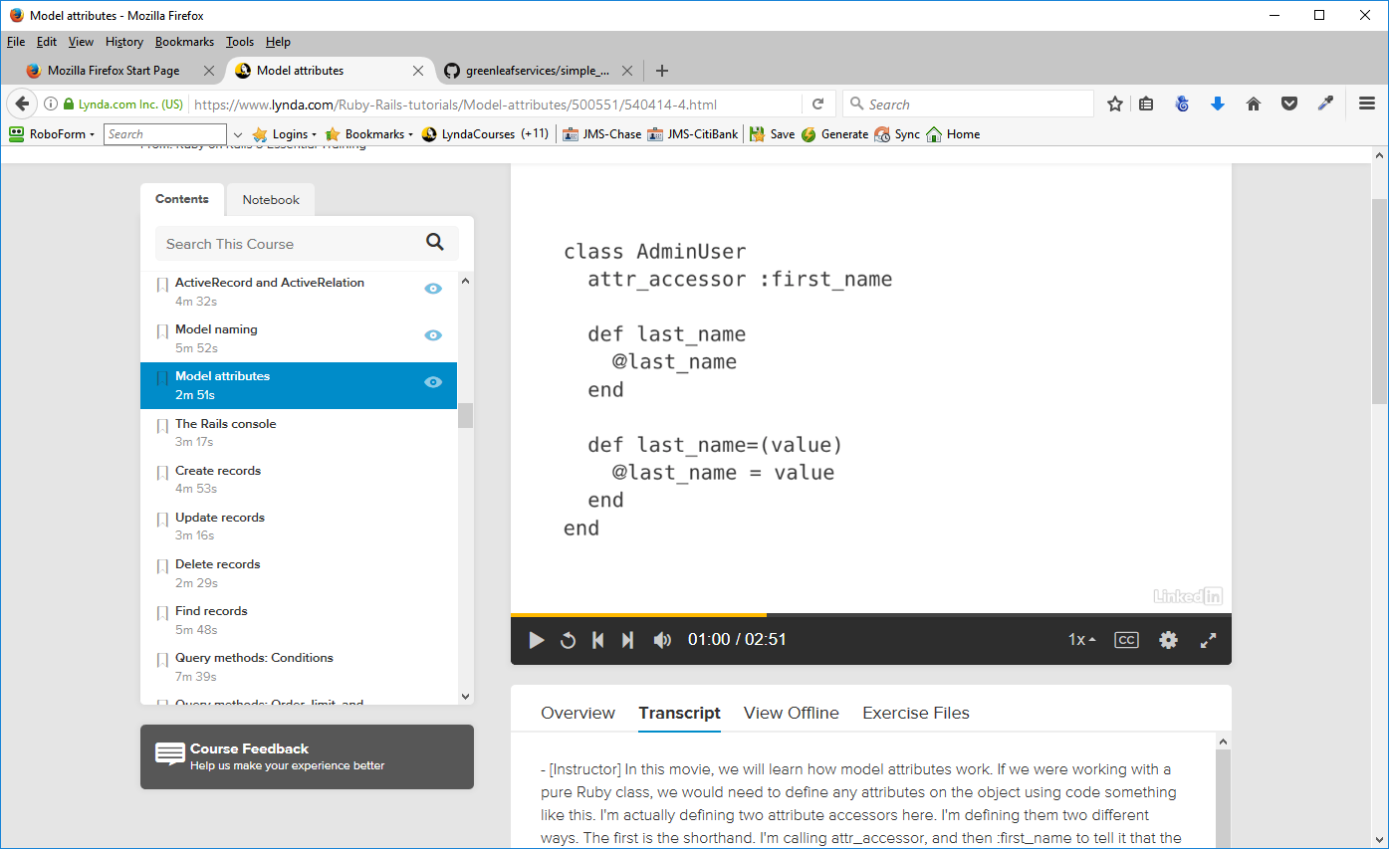

In our Rails model, when we inherit from ActiveRecord::Base we gain a lot of behaviors and abilities that are built-in to ActiveRecord::Base. We already saw that one of those is that it knows where to locate the database table that corresponds to the model.
It also knows what that database table looks like, and it knows what columns exist on the table. And it can use those columns to automatically provide us with attributes and the attribute methods that go with it. So we have a class AdminUser and it inherits from ActiveRecord::Base. It's going to look for a corresponding AdminUsers table, and if we have column for first_name on that table, then it will automatically give us attribute readers and writers for first_name. And it does it for every single column that's on the database.
Not only does it know that they are there, it also knows how to typecast them correctly so that values go into the database and come out of the database with the right type.

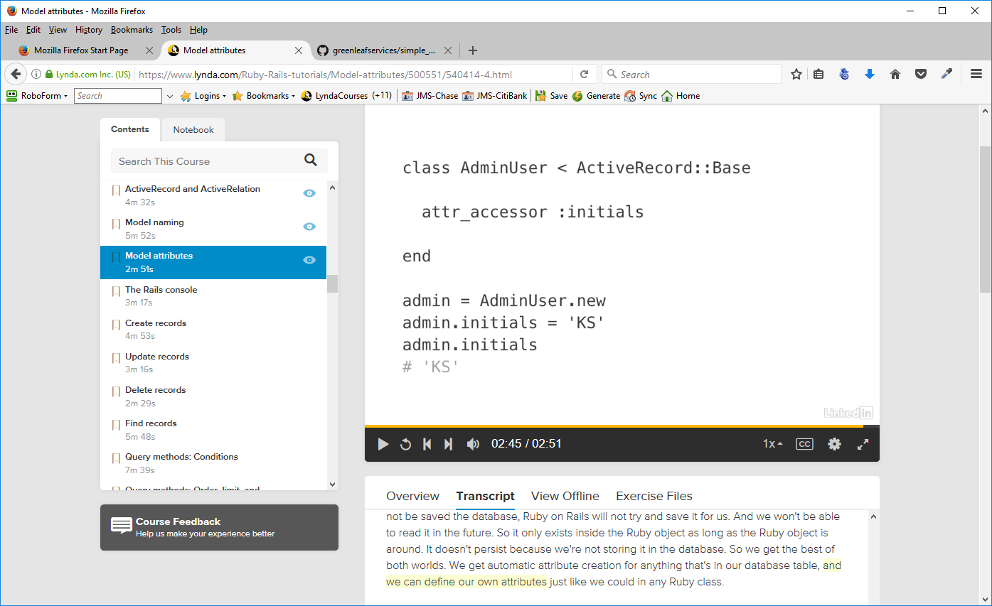
We can still define our own attribute accessors as well. For example, here we've defined one called :initials. And we can set and read values to it just like we would with any Ruby object.

he difference though, is that :initials doesn't have a column in the database. So this data will not be saved the database, Ruby on Rails will not try and save it for us. And we won't be able to read it in the future. So it only exists inside the Ruby object as long as the Ruby object is around. It doesn't persist because we're not storing it in the database. So we get the best of both worlds. We get automatic attribute creation for anything that's in our database table, and we can define our own attributes just like we could in any Ruby class.

The Rails Console
The Rails Console, is a powerful tool, which allows us to work with our models directly, without having to worry about having controllers and views.

From the windows command prompt – not gitBash

rails console development
rails console
rails c

All three above do the same thing because rails assumes the development environment. It will open an irb (interactive Ruby) session with the Rails development environment loaded also. We have access to not just Ruby, but also all of our rails, models and other code.

Loading development environment (Rails 5.0.1)
irb(main):001:0>

We can issue regular ruby commands we can also do

subject = Subject. new

It will use our subject model that's defined in our application, in order to create a new instance of this class.
=> #<Subject id: nil, name: nil, position: nil, visible: false, created_at: nil, updated_at: nil>

subject.name = Test
=> "Test"
subject.name
returns the value test to us.
=> "Test"

This is a good way to test and try things out, and poke and prod at our models. And we don't need to have a controller, or a view, or bring it up in a browser, in order to interact with your models. We get a much more direct relationship with them. And that can be really helpful. To remove those other aspects of it, to get right in with our models, and see what's going on.
If we were to save this subject to the database, it would save it, and it would save it to our development database. Just because we're inside our console, doesn't mean that we are interacting with a different database, than if we were coming at it with a controller and a view.

Create Records
We can use the Rails console to access our models and to create new records in the database. There are two different techniques to accomplish this.

New/save

It's a three-step process. First, we instantiate an object ==> create a new object of the class. This object is also called an instance of the class.
Then we can set values on that instance.
Then when we have all the values set, we save the object to the database.
subject = Subject. new
subject = Subject. new_record?
=> true – the record has not yet been saved to the database
subject.name = "First Subject"
=> "First Subject"
subject.name
=> "First Subject"
You can also combine creating and adding data to the reord in one command
subject = Subject.new(:name => "First Subject', :position => 1, :visible => true)
#<Subject id: nil, name: "First Subject", position: 1, visible: true, created_at: nil, updated_at: nil>

subject.save
(0.0ms) BEGIN
SQL (1.0ms) INSERT INTO `subjects` (`name`, `position`, `visible`, `created_at`, `updated_at`) VALUES ('First Subject', 1, 1, '
2017-03-04 17:09:30', '2017-03-04 17:09:30')
(0.0ms) COMMIT
=> true
irb(main):007:0>

Create
we instantiate an object, set its values, and save it all in one step
subject = Subject.create(:name => "First Subject”, :position => 1, :visible => true)
(0.0ms) BEGIN
SQL (1.0ms) INSERT INTO `subjects` (`name`, `position`, `created_at`, `updated_at`) VALUES ('Second Subject', 2, '2017-03-04 17:14:35', '201
7-03-04 17:14:35')
(1.0ms) COMMIT
=> #<Subject id: 2, name: "Second Subject", position: 2, visible: false, created_at: "2017-03-04 17:14:35", updated_at: "2017-03-04 17:14:35">

Inserts and writes the record – one step process

Update Records
There are two techniques that we can use for updating.

Set the attributes one at a time, and then save.
find save
subject = Subject.find(1)
issues an SQL command in order to find it andcreates a new instance of the object for us to work with, populated with the correct values from the database.

Change the name of the subject name
subject.name = "Initial Subject"
=> "Initial Subject"
subject.new_record?
=> false
subject.name
=> "Initial Subject"
subject.save
(0.5ms) BEGIN
SQL (1.5ms) UPDATE `subjects` SET `name` = 'Initial Subject', `updated_at` = '2017-03-04 19:03:18' WHERE `subjects`.`id` = 1
(1.0ms) COMMIT
=> true
Notice that it writes a SQL UPDATE statement

Set the attributes and save it all at once.
subject = Subject.find(2)
subject.update_attributes(:name => 'Next Subject', :visible => true)
(0.0ms) BEGIN
SQL (0.0ms) UPDATE `subjects` SET `name` = 'Next Subject', `visible` = 1, `updated_at` = '2017-03-04 19:14:12' WHERE `subjects`.`id` = 2
(0.0ms) COMMIT
=> true
subject.name
=> "Next Subject"
subject.new_record?
=> false

Notice that this time, it writes its update statement, and it returns true. Also notice that it doesn't include all of the values when it updates, it only includes the necessary values that need updating. Any attributes that haven't changed are left out of that update statement.

Delete Records
Deleting records is a two step process and we call it find and destroy. There's finding the record, just like we when we were updating the record, and then we destroy the record.
There's also a method in Rails called delete and it may seem to work the same as destroy does. But delete bypasses some Rails features and might give you unexpected behavior. Destroy is the best method to stick with as a beginner.

subject = Subject.find(3)
Subject Load (0.5ms) SELECT `subjects`.* FROM `subjects` WHERE `subjects`.`id` = 3 LIMIT 1
=> #<Subject id: 3, name: "Bad Subject", position: nil, visible: false, created_at: "2017-03-04 19:20:13", updated_at: "2017-03-04 19:20:13">
subject.destroy
(0.5ms) BEGIN
SQL (0.5ms) DELETE FROM `subjects` WHERE `subjects`.`id` = 3
(0.5ms) COMMIT
=> #<Subject id: 3, name: "Bad Subject", position: nil, visible: false, created_at: "2017-03-04 19:20:13", updated_at: "2017-03-04 19:20:13">

Notice that the object is still available, even though it is no longer in database
subject.name
=> "Bad Subject"

However, we cannot modify the record
subject.name = "test"
RuntimeError: Can't modify frozen hash

So, the record has been deleted from the database.

Find Records
Active Record offers us many tools to make finding the right records easier. Thee are a variety of methods to find records (construct queries) in Rails.

The first is the primary key finder. We use class name then a dot and then find and find is going to expect the primary key that we want to user to find the record.
Subject.find(3)

The second is to use dynamic finders. Dynamic finders allow you to be able to find records by different attributes. They always start with find_by_ and then the attribute that you want to search on.
Subject.find_by_name(“First Subject”)
You use it when you want to allow and handle the possibility that the record doesn't exist. It doesn't raise an error if it's not there. It just returns nothing back to you(nil), and then it's up to you to decide what you want to do with it

The third is to just find all records
Subject.all
this will return an array of objects. It will get all of the subjects out of the database and it will instantiate them all into Ruby objects, put then in an array, and return the array to us. And, we can also find first and last by using Subject.first and Subject.last. This will either return an object or it will return nil.
The fourth is find first or last
Subject.first
Subject.last
These will return the requested object or nil

Query Methods:Conditions
Conditions let you specify the criteria that the data must meet to be part of the query results. So we use the method where, and then tell it what conditions it ought to meet.

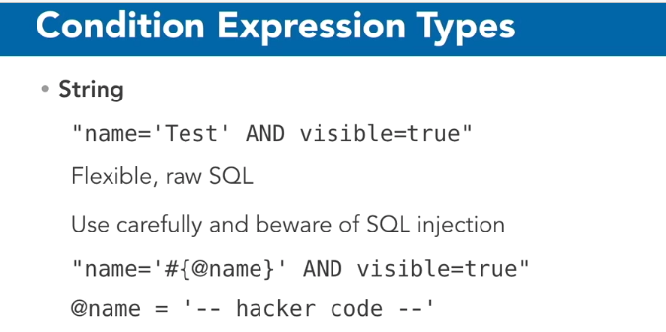
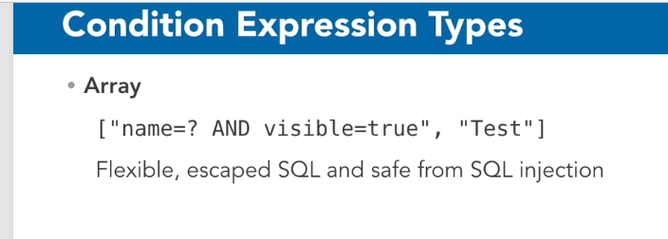

So these are the two most flexible approaches because we can really put any SQL we want in there, but if we don't need that flexible of an approach, we may be better off just using the simplicity of a hash.
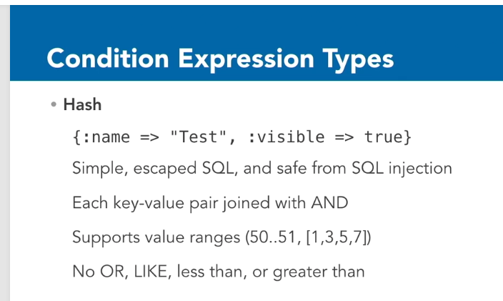

Another important point about conditions is that they return an ActiveRelation, which can then be chained together. So for example, we can have User.where last name is Smith, and then we can have a dot, and right after that we can follow it with another where statement, where first name is John. The reason we can do this is because the where clause does not execute the database call immediately.

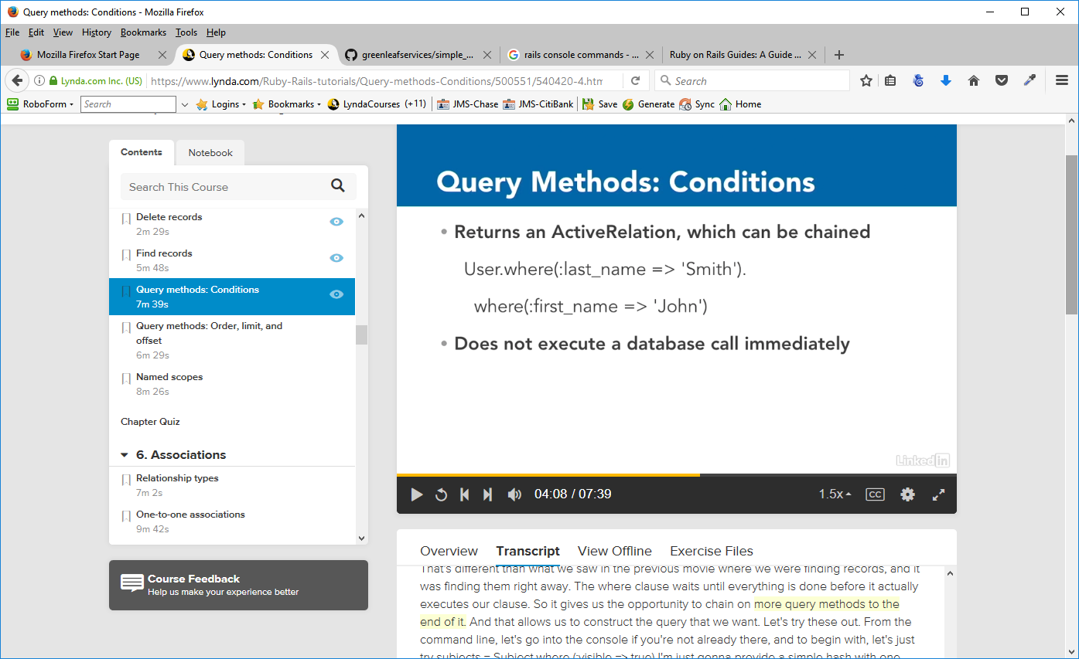
Query Methods: Order, Limit and Offset
There are three additional query methods that are helpful in allowing us to find exactly the records we want, and those are order, limit, and offset.

Order is going to specify the sort order of the returned records. We can sort the records by any column, ID, name, position, created at, etc. We can sort them alphabetically, or reverse alphabetically, ascending, or descending, chronologically, or reverse chronologically.

Limit will limit the results that are returned. This becomes especially important when there are a lot of records which match our conditions.

Offset lets us skip over records before selecting the results to return.

SQL table disambiguation – when you have the same field name in multiple tables, you have to specify the table and field name in the query.

Named Scopes
Simple queries use the built-in methods provided by ActiveRecord and ActiveRelation. Rails gives us these features for free, simply by defining a model so that it inherits from ActiveRecord::Base, which most of our models will.
We can also write your own query methods, which can use and combine the built-in query methods. We can design a query and then save it in our models as a named scope.
Named scopes assign a name to an ActiveRelation query and then store them in a model. We can call named scopes just like we call ActiveRelation query methods, and we can even daisy-chain them together with other ActiveRelation query methods.

Scopes are queries that you store in the models that can be called when necessary.
In the subject.rb model

scope :visible,-> { where(:visible => true) }
scope :invisible, -> { where(:visible => false) }
scope :sorted, lambda { order("position ASC") }
scope :newest_first, lambda { order("created_at DESC") }
scope :search, lambda {|query| where(["name LIKE ?", "%#{query}%"]) }

The word lambda can be replaced by →
In the search scope, we see an example of an argument. We need to have our query string, where, and then we're use the array [“name LIKE ?”, and then the string to drop in place is going to have percent signs on either side of it, which will indicate to SQL that it should use wildcard matching. Because this is dynamic data, it might be coming from a user, we want to make sure that we use the question mark form in order to sanitize it.

Note: to run any new scopes, you must close the rails console and reopen it

Associations

Relationship Types
There are three main relational database types, one-to-one, one-to-many, and many-to-many. ActiveRecord provides something called associations that allow us to define these relationships.

To help us visualize each one, we start with a concrete example. Imagine a school. Each classroom in the school is assigned a teacher. The teachers don't change classrooms, and each teacher teaches four classes per day.
The students change classrooms throughout the day as they move from course to course.

One-to-One ==> (1:1)
An example of this relationship between the classroom and the teacher. There's one teacher that's assigned to each classroom, so the classroom has one teacher. Not more than one, only one. Each teacher belongs to a classroom. We would need to have a foreign key in order to maintain this relationship. The foreign key would go on the teachers table. If our other table is called the classrooms table, then the foreign key would called classroom_ID. The foreign key goes on the belongs to side of the relationship.

One-to-Many ==> (1:M)
An example of a one-to-many relationship is the relationship between each teacher, and the four courses that that teacher teaches. You would say that a teacher has many courses. In our case, Teacher A has algebra, geometry, physics, and programming, and each one of those courses belongs to Teacher A . Once again, we need a foreign key to maintain this relationship, and that foreign key is going to go on the belongs to side of the relationship, it would go on the courses table ==> teacher_id

Many-to-Many ==> (M:N)
An example of a many-to-many relationship is the assignment between courses and the students who are taking those courses. Let's say that we have four courses, chemistry, geometry, physics, and programming, and we have four students, Michael, Jennifer, Jason, and Amy. Let's say that Michael is taking chemistry, geometry, and physics. Now, there's a little bit of a problem, because if we put a foreign key on the courses table to maintain the relationship between Michael and chemistry, then what would we do when Jennifer also wants to take chemistry? Chemistry's ID would already be pointing at Michael, so we couldn't do that, we would have to have many foreign keys, and if we have 100 students trying to take this course, we would need to have 100 foreign keys.
We can't really put the foreign key on the other side either, with the students, because we can't say that Michael belongs to chemistry, because Michael also wants to take geometry and physics. We run into this problem where we can't really put the foreign key on either side. The solution is to use a join table that goes in the middle. The join table is what maintains these relationships. It holds two foreign keys, one foreign key for chemistry, and one foreign key for Michael.
When we have a many-to-many association like this, we say that a course has many students, and belongs to many students, and on the reverse side, we say that a student has many courses, and belongs to many courses.

Corresponding Active Record Associations

One-to-One
classroom has_one :teacher
teacher belongs_to :classroom

One-to-Many
teacher has_many :courses
course belongs_to :teacher

Many-to-Many
course has_and_belongs_to_many :students
student has_and_belongs_to_many :courses

One-to-One Associations
For unique items that a person or a thing can have only one of.
To break up a single table – easier access of certain data (Zip Codes, etc.)

Practice:
We'll pretend that a subject can have only one page associated with it, and the page will belong to a subject. There are two tips to remember before we start defining associations.
The first is you want to make sure that any class with a belongs_to should be the side that has the foreign key.
The second tip is to always define both sides of the relationship. We don't want to just say that the subject has one page and leave it at that. We also want to tell the page about it's relationship back to the subject, so that it goes both ways.

Subject Model – add line has_one :page
Page Model – add line belongs_to :subject
Now, we've made the relationship in both directions and Rails knows how to move between the two. We've already added our foreign key to the pages table and we gave it a name of subject_id. Because we followed that convention, Rails knows where to find the foreign key that it needs to make this relationship.

Create a subject instance
subject = Subject.find(1)
Subject Load (0.5ms) SELECT `subjects`.* FROM `subjects` WHERE `subjects`.`id` = 1 LIMIT 1
=> #<Subject id: 1, name: "Initial Subject", position: 1, visible: true, created_at: "2017-03-04 17:09:30", updated_at: "2017-03-04 19:03:18">
Check to see if there is any link to the pages table
subject.page
Page Load (0.5ms) SELECT `pages`.* FROM `pages` WHERE `pages`.`subject_id` = 1 LIMIT 1
=> nil
No link yet

Make up a page that can link to the subject table

first_page = Page.new(:name => "First Page", :permalink => 'first', :position => 1)
=> #<Page id: nil, subject_id: nil, name: "First Page", permalink: "first", position: 1, visible: false, created_at: nil, updated_at: nil>
We used new here, we didn't use create. So it has not been saved to the database. Notice that it has that foreign key of subject_id, and currently that's set to nil.
It doesn't have a subject ID. We see that also if we do first_page.subject_id, and we can call first_page.subject and it will return the subject object if it's there.

Now notice it did not have to make another database call, it did not go to the SQL database, it didn't need to. Because it knew that subject_id was equal to nil. So it knew there was no reason to look for the subject record to which it was linked through the foreign key in the database. If it had had an ID, then it would have gone to the database to find information about that subject. Now let's make the assignment.

subject.page = first_page
(0.5ms) BEGIN
SQL (1.0ms) INSERT INTO `pages` (`subject_id`, `name`, `permalink`, `position`, `created_at`, `updated_at`) VALUES (1, 'First Page', 'first', 1, '2017-03-05 16:31:17', '2017-03-05 16:31:17')
(0.5ms) COMMIT
=> #<Page id: 3, subject_id: 1, name: "First Page", permalink: "first", position: 1, visible: false, created_at: "2017-03-05 16:31:17", updated_at: "2017-03-05 16:31:17">

Notice that we get back a representation of the object, and it says subject_id: 1. It has that foreign key there.

Now
first_page.subject_id
=> 1
first_page.subject
=> #<Subject id: 1, name: "Initial Subject", position: 1, visible: true, created_at: "2017-03-04 17:09:30", updated_at: "2017-03-04 19:03:18">

Also notice that the SQL statement in the assignment command inserted the record into the database. hat's because when we make the association, it gets the primary key from the subject, it sets it as the foreign key on pages, and then it saves the associated page's object to the database. So it's very important when we make the association it does try to save the object.

subject.page
=> #<Page id: 3, subject_id: 1, name: "First Page", permalink: "first", position: 1, visible: false, created_at: "2017-03-05 16:31:17", updated_at: "2017-03-05 16:31:17">

Therefore, putting the lines in the subject.rb and the page.rb files creates the relationship between the two tables and rails will follow that rule and create the association when creating a new page.

To remove the association

subject.page =nil
(0.0ms) BEGIN
SQL (2.0ms) UPDATE `pages` SET `subject_id` = NULL, `updated_at` = '2017-03-05 16:42:12' WHERE `pages`.`id` = 3
(1.0ms) COMMIT
=> nil

By setting it to nil it will remove the association. It updates our pages table, it sets the subject_id equal to NULL. Now it's not set anymore.

We ask for subject.page, it will return nil to us. Now it removed the relationship, it did not remove the page's record. We can see that if we run Page.All

If we wanted to not only break the association, but we wanted to remove the record, well then we would need to use destroy to do that.

Repeat the steps above to create the association and then
subject.page.destroy
(0.0ms) BEGIN
SQL (3.0ms) DELETE FROM `pages` WHERE `pages`.`id` = 4
(1.0ms) COMMIT
=> #<Page id: 4, subject_id: 1, name: "First Page", permalink: "first", position: 1, visible: false, created_at: "2017-03-05 16:48:15", updated_at: "2017-03-05 16:48:15">

Now Page.all will no longer show that page in the database.

One-to-Many Associations
One-to-many associations are similar to one-to-one associations, but there are a few main differences.
First, one-to-many associations will be much more commonly used. In a typical application, we rarely use one-to-one, but we use one-to-many the most often.
Second, because we have one object related to many objects, we're going to use plural names. That's true when we define the association and also when we call the methods on it.
Third, the relationship is going to return an array of objects back to us instead of a single object.

Our subject-page relationship is going to be a one-to-many relationship. Each subject has_many pages, and a page belongs_to a subject. Each page also has_many sections, and each section belongs_to a page. Whenever you see belongs_to, remember, that's your tip on where to put the foreign key.

Methods of One-to-many associations – Note the plural in pages
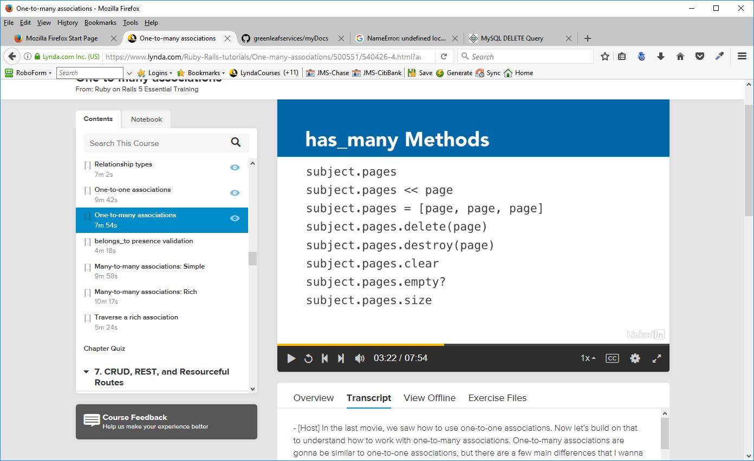
Creating the associations
In subject odel (subject.rb)
has_many :pages ==. changed from has-One:page in the previous section

No change need in page model (page.rb)

Practice:
In rails console – get an instance of the subject

subject = Subject.find(1)
Then look for any pages associated with that object
subject.pages
Page Load (0.5ms) SELECT `pages`.* FROM `pages` WHERE `pages`.`subject_id` = 1
=> #<ActiveRecord::Associations::CollectionProxy []>

Rails returns an empty array
Create a page
first_page = Page.new(:name => "First Page", :permalink => 'first', :position => 1)

Now use the append operator to append this page to the subject object
subject.pages << first_page
(0.0ms) BEGIN
SQL (1.0ms) INSERT INTO `pages` (`subject_id`, `name`, `permalink`, `position`, `created_at`, `updated_at`) VALUES (1, 'First Page', 'first', 1, '2017-03-05 17:12:10', '2017-03-05 17:12:10')
(0.5ms) COMMIT
=> #<ActiveRecord::Associations::CollectionProxy [#<Page id: 5, subject_id: 1, name: "First Page", permalink: "first", position: 1, visible: false, created_at: "2017-03-05 17:12:10", updated_at: "2017-03-05 17:12:10">]>

belongs_to presence validation
Prior to Rails 5.0 an object that had a belongs to relationship could be saved to the database even if it didn't have a parent object associated with it. That is the belongs to relationship was not required To be present. Now, starting in Rails 5, the belongs to relationship is not optional by default, what happens behind the scenes is that when we declare a belongs to, active record adds a validation on the object for the related objects presence... The parent object. So if we have our page that means that the page won't save to the database. Unless we have a subject associated with it.
A validation is there to check and make sure that the data is correct before allowing the record to be saved to the database. So, if the subject is not present, then the page can't be saved. Now again, this is set to not optional by default. You can disable this option. And there's two ways you can do it.

One, you can do it as a configuration change. And you can do it for your entire application.

Demonstration:

Rails console

page = Page.new(:name => "No Subject Assigned")
=> #<Page id: nil, subject_id: nil, name: "No Subject Assigned", permalink: nil, position: nil, visible: false, created_at: nil, updated_at: nil>
page.save
(0.0ms) BEGIN
(0.5ms) ROLLBACK
=> false

page.errors.full_messages
=> ["Subject must exist"]

That's the error that kept us from saving to the data base, so there's two solutions to this.
One, we could assign the page to a subject, like we did in the last section. And then the page would be saved automatically.
The other possibility is that we could go into the page model, and after belongs to subject, right now, the default in Rails is optional, false it's not optional, we would just need to change that to be true.
belongs_to :subject, { :optional => false }
So, belongs to subject optional true, and that would mean that we could save pages to our database without having a parent object, a subject, that it belongs to. Be careful about disabling this feature though, it's there for protection. It's to keep you from putting orphaned records in your database. To have pages in there that don't belong to any subject.

Many-to-Many Associations: Simple
Many-to-many associations are similar to one-to-many associations because they also have an object which has many objects which belong to it. The difference that as a many-to-many, the objects don't belong to it exclusively.

When we talk about many-to-many, we're essentially talking about having two different sets: a set of projects and a set of collaborators. It's going to be very similar to working with a one-to-many association, but it's a one-to-many association from both sides at the same time.

Question: Where to put the foreign key. We need to put it in a join table, and the join table is going to hold two foreign keys that are going to relate to the two different sides of the association. We're going to put an index on both of those keys so that we can look them up very quickly.

Demonstration:
Two tables, admin_users and pages ==> admin_users will be able to edit a page. So there will be a relationship between a page and the users who can edit the page. It won't be an exclusive relationship because each of those users also has the ability to edit other pages. So we have adminUser has_and_belongs_to_many :pages and a page has_and_belongs_to_many :admin_users. Just like with our other associations, be sure that you define both sides of the relationship so that you can move both ways from admin_user to pages and from page back to admin_users.

In order for this process to work, we have to create a migration for the join table used in this relationship. We can name your join table anything you want, but Rails has a convention that we should try and follow - to use the name of the first table being joined, then an underscore, and then the second table name. Both table names are plural, and they're expressed in alphabetical order. That's important. This is the default naming, and it can be configured.

In Command Prompt – not in Rails Console
rails generate migration CreateAdminUsersPagesJoin
This will create the migration requested with the following lines
class CreateAdminUsersPagesJoin < ActiveRecord::Migration[5.0]
def change
create_table :admin_users_pages_joins do |t|
end
end
end
Change it to look like this:
def up
create_table :admin_users_pages, :id => false do |t| ==> don't create an auto index
t.integer "admin_user_id" ==> foreign key for the admin_user table - singular
t.integer "page_id" ==> foreign key for the page table - - singular
end
add_index("admin_users_pages", ["admin_user_id", "page_id"]) ==> index for this table – 2 elements in the array
end
def down
drop_table :admin_users_pages
end
Note that it knows to use the create_table command. That's because of the name we assigned to it at the command prompt. Create is a key word to the migration to tell it that we want to create a table.
Also not the the index for this table has 2 elements in an array – a join table has to have an index that contains a reference to each of the tables in the join.

Finally notice that we since don't need an id on this table (there's no time that we bring up an AdminUsers-Pages object), To do that, we want to make sure that we add id false as an option to the creation. That will turn off the automatic id creation.

After the migration file has been changed
rails db:migrate

Now we go to the model and define the associations
In admin_user model (admin_user.rb) we add the line
has_and_belongs_to_many :pages

In page model (page.rb) we add the line
has_and_belongs_to_many :admin_users

In each of these models, we could specify the join table name (admin_users_pages) but, because we are using Rails conventions, this is not necessary

Create a admin_user record
me = AdminUser.create(:first_name => 'John', :last_name => 'Stegman', :username => 'jstegman')
(0.5ms) BEGIN
SQL (1.5ms) INSERT INTO `admin_users` (`first_name`, `last_name`, `username`, `created_at`, `updated_at`) VALUES ('John', 'Stegman', 'jstegman', '2017-03-05 20:45:35', '2017-03-05 20:45:35')
(0.5ms) COMMIT
=> #<Admin_User id: 3, first_name: "John", last_name: "Stegman", email: "", username: "jstegman", hashed_password: nil, created_at: "2017-03-05 20:45:35", updated_at: "2017-03-05 20:45:35">

Get a page object
page = Page.find(5)

page.admin_users
AdminUser Load (2.0ms) SELECT `admin_users`.* FROM `admin_users` INNER JOIN `admin_users_pages` ON `admin_users`.`id` = `admin_users_pages`.`admin_user_id` WHERE `admin_users_pages`.`page_id` = 1
=> #<ActiveRecord::Associations::CollectionProxy []>

We see the page's current user.==> it's empty, there are none that are assigned yet, but notice that it did go out and it executed a bit of SQL here - it actually has a JOIN clause in it as well. So it went out and it did a JOIN through our join table in order to find the AdminUsers that belong to this page.

Add some Admin_Users

page.admin_users << me
(0.5ms) BEGIN
SQL (1.5ms) INSERT INTO `admin_users_pages` (`admin_user_id`, `page_id`) VALUES (1, 1)
(0.5ms) COMMIT
=> #<ActiveRecord::Associations::CollectionProxy [#<AdminUser id: 1, first_name: "John", last_name: "Stegman", email: "", username: "jstegman", hashed_password: nil, created_at: "2017-03-05 21:36:13", updated_at: "2017-03-05 21:36:13">]>
Now, because it crated a record in the admin_user_pages table (1,1) the tables admin_users and pages are joined at that record.
Even though we interacted with it like it was a has_many relationship, it knew that it was a has_and_belongs_to_many relationship and performed the necessary SQL behind the scenes.

We can also look at the other side of the relationship
me.pages
Page Load (0.5ms) SELECT `pages`.* FROM `pages` INNER JOIN `admin_users_pages` ON `pages`.`id` = `admin_users_pages`.`page_id` WHERE `admin_users_pages`.`admin_user_id` = 1
=> #<ActiveRecord::Associations::CollectionProxy [#<Page id: 1, subject_id: 2, name: "First Page", permalink: "first", position: 1, visible: false, created_at: "2017-03-05 21:33:14", updated_at: "2017-03-05 21:33:14">]>

Using this join table allows us to make non-exclusive many-to-many relationships.

Many-to-Many Associations: Rich

Diagram of many-to-many simple setup

This is a classic many-to-many:simple example. We have a number of courses, we have a number of students taking these courses. There will be a table named courses and a table named students, and in the simple join, we would have a join table between them, which we would call courses_students.

If we want to keep track of more information than just the fact that a student is participating in a class, - their seat number, or the date they signed up, or the date they last attended, or how many times they've been absent. That information belongs in this join table, because the join table is essentially the object maintaining the presence of the student in the course. Everything that has to do with a student and his participation in Chemistry should be stored in that join. This is when we need to switch to a rich join.

One of the benefits of a rich join is that we no longer have to follow Rails table-naming conventions for the join table. Instead, it's a good idea to give it a name that describes the join. In the diagram below, we call it course_enrollments. We're also going to be creating a new model for our course_enrollments. Instead of using has_and_belongs_to_many between course and student, now course will have many course_enrollments, and so will students.

CourseEnrollment is going to have two belongs_to definitions, one for course and one for student. In the previous section, we learned that many-to-many associations work just like has_many associations. Here, that's actually true. They are has_many associations now. CourseEnrollment still serves as a join between them. It's just now a join that can have more richness. It can have more columns in the database, more attributes, and more custom methods stored in that model.
We use rich joins for the same reason that we use a simple join. The difference is only that we get more complexity on the join. Because of that, we need to change the way that we store this relationship in the database. We're going to have a join table still, with two indexed foreign keys, but because it has a model for the join, it's also going to require having a primary key defined, so we will need to have an (:id) now, so that we can create this record, find it, update it, and delete it, just like we can with any active record object. There's no table-naming convention that we need to follow, however, one helpful tip is that rich join table names often will end in "-ments" or "-ships", such as "assignments", "engagements", "authorships", "memberships".

In our test application, we will use rich joins with AdminUser and Section. The idea is that every time an AdminUser updates a Section of the CMS, we're going to keep track of the edit in a table called section_edits. We'll have a model for it called SectionEdit. Then we'll have admin_user has_many :section_edits, and SectionEdit belongs_to :admin_user. Then on the other side of the join, we'll have Section has_many :section_edits, and SectionEdit belongs_to :section.

From command prompt:
rails generate model SectionEdit
This will be used to keep a log of the section edits by any user

Change the CreateSectionEdits model
def up
create_table :section_edits do |t| ==> keep the id
t.integer "admin_user_id"
t.integer "section_id"
t.string "summary"
t.timestamps
end
add_index("section_edits", ['admin_user_id', 'section_id']) ==> foreign keys
end

rails db:migrate
Creates the table section_edits and add the indexes

Define the associations
Admin_user model
add has_many :section_edits
Section-Edit model
add belongs_to :admin_user
add belongs_to :section
Section model
add has_many :section_edits

In rails console:

Get an admin_user object to work with
me = AdminUser.find(1)
Look for section_edits for this user
me.section_edits
This will return an empty array

Create a section record
section = Section.create(:page_id => 3, :name => 'Section One', :position => 1)
(0.0ms) BEGIN
Page Load (0.5ms) SELECT `pages`.* FROM `pages` WHERE `pages`.`id` = 3 LIMIT 1
SQL (1.0ms) INSERT INTO `sections` (`page_id`, `name`, `position`, `created_at`, `updated_at`) VALUES (3, 'Section One', 1, '2017-03-06 14:59:13', '2017-03-06 14:59:13')
(0.5ms) COMMIT
=> #<Section id: 1, page_id: 3, name: "Section One", position: 1, visible: false, content_type: nil, content: nil, created_at: "2017-03-06 14:59:13", updated_at: "2017-03-06 14:59:13">
Note: you have to put in a page_id in the create command because we have the section connected to the page bu the section model. If you try to create a section without specifying the page_id to which it belongs, we'll get a ROLLBACK error because rails requires the page to exist.
Look for section_edits

section.section_edits – we will get an empty array
SectionEdit Load (0.5ms) SELECT `section_edits`.* FROM `section_edits` WHERE `section_edits`.`section_id` = 1
=> #<ActiveRecord::Associations::CollectionProxy []>

When we were working with our simple join the two join objects interacted with each other, and Rails managed the simple join for us, adding or deleting rows as necessary.
With the rich join, we have a model that we work with to manage that join ourselves, so in order to work with this join, we have to create a new edit.

Create an edit object
edit = SectionEdit.new

Enter data into the summary field
edit.summary="Test edit"

Attach it to the section
section.section_edits << edit

This does not work because the section_edit is attached to the admin_user table and we have to specify an admin_user for this edit in order for it to be attached to the section_edits. The section is also required but that ix a current object so it will have that, but, again, there's not admin_user specified.

One good way to do this is just to specify it right from the beginning

SectionEdit.create(:summary => "Test Edit", :admin_user => me, :section => section)
(0.5ms) BEGIN
SQL (1.0ms) INSERT INTO `section_edits` (`admin_user_id`, `section_id`, `summary`, `created_at`, `updated_at`) VALUES (1, 1, 'Test Edit', '2017-03-06 15:56:15', '2017-03-06 15:56:15')
(0.5ms) COMMIT
=> #<SectionEdit id: 1, admin_user_id: 1, section_id: 1, summary: "Test Edit", created_at: "2017-03-06 15:56:15", updated_at: "2017-03-06 15:56:15">

Look for the admin section_edits
me.section_edits.reload
SectionEdit Load (0.5ms) SELECT `section_edits`.* FROM `section_edits` WHERE `section_edits`.`admin_user_id` = 1
=> #<ActiveRecord::Associations::CollectionProxy [#<SectionEdit id: 1, admin_user_id: 1, section_id: 1, summary: "Test Edit", created_at: "2017 -03-06 15:56:15", updated_at: "2017-03-06 15:56:15">]>

Look for the section section_edits
section.section_edits
=> #<ActiveRecord::Associations::CollectionProxy [#<SectionEdit id: nil, admin_user_id: nil, section_id: 1, summary: "Test Edit", created_at: nil, updated_at: nil>]>

Transversing a Rich Association
We have created a rich join between admin users and sections by using section_edits. While we gain the ability to add complexity of other attributes and methods inside our section_edit model, we lost something at the same time. We now have to go through an extra step to get from one side of the association over to the other.
For example, in a simple, has and belongs to many join, if we wanted to know all of the admin users who could edit a page, we could just request the array of admin users, page.admin users and we'd get back an array.
It would reach across the join table to the other side of the association.
But in our rich join, we can't just ask for section's admin users because there is no direct relationship between section and admin user. There's a model that's in between now. We can still do it, we just have to go through that extra step of going through the section edits and looking up each one's admin user. What we really want, is a way to reach across the join easily to be able to access the admin users by just calling section.admin users.

It's just a question of telling ActiveRecord about the relationship, so that it can modify the SQL it writes and treat this rich join like a simple join some of the time.
Rails gives us a tool for this using has_many:through. It allows reaching across a rich join and treating it like it's a has_and_belongs_to_many join.

The first step, is to create the regular functional rich join first ==>
In the admin_user model we already have
admin_user – has_many :section_edits

After that, we can add in another relationship using has_many:through.
has_many :sections, :through => :section_edits

This defines the admin_user relationship to sections. We're telling it that it can reach through section edits to get to the other side of the relationship. Admin user now has many sections. It's a has_many relationship. We have all the same methods and the same functionality we're used to when we have a has_many. It's just doing it by going through the section edits' join table.

The same thing is true from the other side. A section has many section edits and then we can have section has many admin users through section edits.
In sections model
has_many :admin_users, :through => :section_edits

In Rails Console
get an Admin_user object
me = AdminUser.find(1)

look for section_edit for this user object
me.section_edits
SELECT `section_edits`.* FROM `section_edits` WHERE `section_edits`.`admin_user_id` = 1
=> #<ActiveRecord::Associations::CollectionProxy [#<SectionEdit id: 1, admin_user_id: 1, section_id: 1, summary: "Test Edit", created_at: "2017-03-06 15:56:15", updated_at: "2017-03-06 15:56:15">]>

look for sections associated with this user object
me.sections
Section Load (0.5ms) SELECT `sections`.* FROM `sections` INNER JOIN `section_edits` ON `sections`.`id` = `section_edits`.`section_id` WHERE `section_edits`.`admin_user_id` = 1
=> #<ActiveRecord::Associations::CollectionProxy [#<Section id: 1, page_id: 3, name: "Section One", position: 1, visible: false, content_type: nil, content: nil, created_at: "2017-03-06 14:59:13", updated_at: "2017-03-06 14:59:13">]>
Rails now modifies the SQL that it writes. It now creates that join table (relationship) and it goes through that to find the sections and it returns us a list of these sections.

We can look at this from the other side of the relationship

section = Section.first
Section Load (0.5ms) SELECT `sections`.* FROM `sections` ORDER BY `sections`.`id` ASC LIMIT 1
=> #<Section id: 1, page_id: 3, name: "Section One", position: 1, visible: false, content_type: nil, content: nil, created_at: "2017-03-06 14:59:13", updated_at: "2017-03-06 14:59:13">
section.section_edits
SectionEdit Load (0.5ms) SELECT `section_edits`.* FROM `section_edits` WHERE `section_edits`.`section_id` = 1
=> #<ActiveRecord::Associations::CollectionProxy [#<SectionEdit id: 1, admin_user_id: 1, section_id: 1, summary: "Test Edit", created_at: "2017-03-06 15:56:15", updated_at: "2017-03-06 15:56:15">]>
section.admin_users
AdminUser Load (0.5ms) SELECT `admin_users`.* FROM `admin_users` INNER JOIN `section_edits` ON `admin_users`.`id` = `section_edits`.`admin_user_id` WHERE `section_edits`.`section_id` = 1
=> #<ActiveRecord::Associations::CollectionProxy [#<AdminUser id: 1, first_name: "John", last_name: "Stegman", email: "", username: "jstegman", hashed_password: nil, created_at: "2017-03-05 21:36:13", updated_at: "2017-03-05 21:36:13">]>

In practice, most of the time when you're going to use the => through is when you're reading back data. When you want to just reach across the join and read what's on the other side.
When you're actually creating data, you probably want to add all those attributes and the richness that's in that rich join in the middle.

CRUD, REST and Resourceful Routes

CRUD

We're going to be dividing the CRUD for subjects, pages, and sections into three separate controllers. The subjects controller, the pages controller, and the sections controller. You typically have one controller per model.
It helps you to keep your code organized. And we're going to use plural names for your controllers. Notice it's subjects controller not subject controller because we are controlling all of our subjects with this controller not just one. This also allows for common sense URLs. For example, we will have subjects/new, pages/new, and sections/new, subjects/edit, pages/edit, and sections/edit and so on. These URLs clearly define the model which is being manipulated and the action which is being performed on it.

Generating controllers
We will use the option with which we can specify the views that we want it to create at the same time.
>rails generate controller Subjects index show new edit delete

the other three - create, update and destroy don't actually have specific views associated with them. Those are just actions which do the form processing. So we don't need to have a view generated for them, just these five.

Creates the html.erb files for the views and also some supporting coffee and javascript files.

Because we didn't use the create update and destroy in the generate controller line we need to add those methods in the Subjects controller

We also need to add them to the routes.rb file – the generate created placeholders for the new we specified in the command line but we need to add ones for the other three – to do that we use REST

REST
REST is short for Representational State Transfer, and REST is a design concept which says that our application should not focus on performing procedures, but instead on performing state transformations upon resources.

In most websites, we write a webpage in which the user triggers an action, that is, performs a procedure. And that procedure could be anything. It could be a long page of unstructured and unorganized code which updates many different database tables at a time. REST asks us to be more organized and to think about our data as resources, and then to think about making changes to those resources. We're already doing that by having distinct models and writing distinct CRUD actions in our controllers to change those models.

To start using REST, there are four changes to our way of thinking and to our code that we'll need to make. - First is that we need to organize our code into resources. We're already doing that. We've got a distinct table in our database for each resource. Each table has a model, and we just set up having one controller per model.
- Second we're going to need to learn some HTTP verbs for working with those resources and learn about how our CRUD actions map to each one.
- Third we'll need to learn about a new URL syntax for our controller actions, and that's going to influence the way that we write our Rails routes.
- Fourth we're going to need to modify our existing links and our forms to use that new syntax.

GET requests are the only pages we want to let the serve cache for faster delivery or allow our users to bookmark.
In REST, POST is only used to create a new item.
PATCH is used to update an existing item
DELETE is used when we want to delete an item.

Why not just use POST? Because we want to reserve POST for an operation on our resource that should really only be run one time such as adding a new item.

How these verbs map to our basic CRUD actions.

Even though HTTP and most web servers support the four REST verbs, different HTML versions have varying levels of support for REST, therefore, Rails uses a work around so that we can use REST universally.
It fakes a true REST request by adding a hidden field called _method to the form, and then it uses the POST as the method for the form. This hidden field indicates to Rails whether it's meant to actually be a PATCH or DELETE. So the form uses POST, but when Rails gets the request and sees that hidden field, it knows to treat it like the REST method you've specified. This is a minor technical point. In reality, you won't worry about it much. When we learn to work with forms later, Rails offers us form helpers which will take care of making these adjustments for us.

Resourceful Routes
Rails gives us a convenient shortcut that we can use in our routes file in order to define resourceful routes.
resources :subjects
resources :pages
resources :sections
These shortcuts create standard routes, which map to our CRUD actions using REST HTTP verbs.
A route is now a combination of the URL and that HTTP verb that goes with it. For example, show, update, and destroy all have the exact same URL. Notice that it's the HTTP method, GET, PATCH, and DELETE, that makes the difference. And the same thing is true for index and create. They have the same URL. It's the verb that makes the difference. The ones that do still show an action, new, edit, and delete, are really just conveniences for us to have a place to compose our changes in our browser.

There are two different types of routes that we can add.
Member routes operate on a member of the resource. In other words, they expect to receive a record ID in the URL. Edit and update are examples of built-in routes that are member routes.
Collection routes operate on the resource as a whole. In other words, they do not expect to get a record ID in the URL. Index is an obvious example of a built-in member route, but new and create also operate on the collection as a whole, not on an existing member.

Demonstration: Adding a resourceful route
routes.db
Add the following:
resources :subjects do # default
member do
get :delete #should be added ,no part of default resources
end
end
This will give us all 8 of the CRUD actions in the Subjects Controller – controller.rb
To view the routes we have
rails routes
Rails will tell us all the routes that it knows about, every mapping that we have. It can be very useful, especially when working with resourceful routes.
Prefix Verb URL Pattern Controller#Action
root GET / demo#index
delete_subject GET /subjects/:id/delete(.:format) subjects#delete
subjects GET /subjects(.:format) subjects#index
POST /subjects(.:format) subjects#create
new_subject GET /subjects/new(.:format) subjects#new
edit_subject GET /subjects/:id/edit(.:format) subjects#edit
subject GET /subjects/:id(.:format) subjects#show
PATCH /subjects/:id(.:format) subjects#update
PUT /subjects/:id(.:format) subjects#update
DELETE /subjects/:id(.:format) subjects#destroy

Resourceful URL Helpers
One benefit to using resourceful routes is how much typing it saves us. And the reason why that's possible, is because of Rails sensible defaults and because there's some good helper methods that we can use in our links and in our forms.
Previously, when we've wanted to generate a link, we wanted to provide a URL. We could either provide a string, that was actually the URL, or we could have Rails construct that for us by giving it a hash. And we would just specify the controller and the action that we wanted and Rails would handle going through the routes file to figure out how to turn that into a URL.
Now, with resourceful routes, we have some helpers that can help even further. Instead of having to write out controller, subjects, action, show, id, 5, we can use the helper and simply say, subject_path(5). And that will generate the exact same URL. But it will reduce the amount of code that we have to write and maintain. So, that's an example of a resourceful URL helper.

The fourth column lists the URL Helper method that Rails provides to generate the correct URL and HTTP verb combination. It's not so different from the URLs themselves, just rearranged a bit to be more readable. But notice one thing important, almost all of them use subject, singular. And that's because they're going to be dealing with a singular member of the resource. In the last chapter, we talked about the difference between member routes and collection routes. With index and create, we're gonna be working with a collection as a whole, either listing the collection or adding a new item to it. So, they use the plural form.
If the fourth column seems like a lot of information that you have a memorize, notice that there's a pattern. And there's really just two main parts.
subjects_path, plural.
subject_path, followed by id as an argument. And it's the singular form.
The other three cases just put new, edit and delete in front, the same way that the resulting URL adds new, edit and delete at the end. Those are the three convenience actions, which simply display a web form to help us to compose data before submitting it.

These URL helpers will allow us to generate the correct URLs. In the examples, we're using our link to helper, instead of providing a hash as an argument, we can use that URL helper to give us the same effect. So, link to, all subjects and then subjects_path is going to create the same string, the same URL in the link that will point to subjects/index. If we wanted to add a query parameter as an argument, then you would just put that in parentheses so it'd be passed in as an argument to the helper method. If we wanted to edit a subject we could use edit_subject_path and then provide either just subject or subject.id

Controllers and CRUD

Read Action:Index
Reading records from the database is usually handled by two standard Rails actions: Index and show. Index displays a list of records, while show displays a detailed view for a single record.
The two actions work together as a common application design pattern. The application displays a list of items, the user clicks a link for one of those items, then the application shows the user a detail page for that item. The user reviews the details, and then clicks a link to go back to the main list.

Subject Controller ==> subject.rb
We want this to find all the subject so that we can list them - the setup that it needs to do for the view is to find those subjects and assign them to an instance variable, so that the view template can access that list.
Create a list called @subjects. The @ symbol in front indicates that it is an instance variable. We tell our subject class that we want to get all subjects and we want that list sorted. In the subject model, we created a named scope already here that's called 'sorted'.
Rails conventions will cause this, by default, look for the index template to render.
Views ==> index.html.erb

This is the template that the subjects controller index action will render by default. We need to add the code which will list out the subjects. See code in project.

Demonstrate: from command prompt
rails server
Open browser and go to localhost:3000/subjects
Command prompt output ==>
Started GET "/subjects" for ::1 at 2017-03-07 08:32:10 -0500
Processing by SubjectsController#index as HTML ==> Rails directive – use SubjectsController, Index action
Rendering subjects/index.html.erb within layouts/application ==> Render the HTML page
Subject Load (1.0ms) SELECT `subjects`.* FROM `subjects` ORDER BY position ASC ==> Get the data (2.0ms) SELECT COUNT(*) FROM `pages` WHERE `pages`.`subject_id` = 1
(1.0ms) SELECT COUNT(*) FROM `pages` WHERE `pages`.`subject_id` = 2
Rendered subjects/index.html.erb within layouts/application (43.0ms)
Completed 200 OK in 1836ms (Views: 1797.7ms | ActiveRecord: 7.0ms)

Browser will display the table with the subject data and the links specified in the HTML code

Read Action:Show
One key difference about show is that it's going to require an ID, and that ID must exist in the database. Otherwise rails would return a record not found error. We need to add that ID (in place of the #) to the show page on the index view template.
<%= link_to("Show", '#', :class => 'action show') %>
Three ways to do this:
- First – add 'subjects/#{subject.id}'. That would generate a URL that had subjects followed by the ID
- Second - Use a hash. {:controller => 'subjects', :action => 'show', :id => subject.id}. Rails would take that hash, it would look at our resourceful routes, and it would determine what that URL ought to look like, and it ought to look like subjects/ ID.
- Third and best way is to use resourceful route helpers from the previous section. We use subject_path (the ID is actually optional) That will generate the URL that we need. It's singular because we're working with a singular subject and because we're working with that singular subject, we have to provide the ID (subject) as the first argument.
Save the changes to index.html.erb and refresh the browser – not the link will show when the mouse is hovered over the link. Clicking on any one of those would create a new request which would be routed to our show action, and the request would include the subject ID (localhost:3000/subjects/2).

In subjects controller, we already have a placeholder for the show action. We know how to find a single subject in the database, we did that from the console earlier, so we just need to add that to our action here.
Add the line @subject = Subject.find(params[:id]) – this will find the id that we pass to it using the built in method of find for the Subject model.
For the show template (show.html.erb), add the appropriate HTML code.
Now, in the browser, when we click on the show link of a subject, Rails will get the data from the database and render the show view – showing the data of the record requested.

Form Basics
Rails/ERB vs HTML
Anything that we can write with the ruby helpers can also be written using simple HTML. That's all the helpers are doing, they're helping us write HTML and the end result that gets sent back to the browser is always just going to be plain HTML.
Also, writing code using these helpers is almost always easier, more powerful, and includes lots of extra benefits than if we use simple HTML alone.

Form using HTML

Form using Rails helpers
We pass in an instance of my subject (@subject). Rails will take that and create the form that we need.
It's also going to do a code block, that's everything from do down to end, and it's going to have a local code block variable which is f and f will be available to us throughout the rest of that block.
F is a form builder object, and it knows about the object that we just created ==> subject. So it's sensitive to that fact.
Each of those texts fields is generated by calling the text_field method on the form builder object, and telling it which attribute we want (name, position and visible). The end result again is exactly the same HTML as above.
But there are a few benefits to it. First, this form_for object knows whether the object is a saved object or not. If it's a saved object, then it knows that we're going to be doing an update action on it. If it's not a saved object, it knows that we're doing a new action, and it adjusts the form accordingly for us.
Also, if it's an existing object, it knows to pre-populate all of those text fields with the existing values. If it's a new object, then it knows not to do that, and it won't bother putting those values in there.
We now will have code that defines one form, but that form can generate a smart, dynamic HTML form for us.

Create Action:New
The create part of CRUD is made up of two standard actions, New and Create, and they work together. The New action displays a web form that we can fill out and submit to the Create action. Create action handles the form processing behind the scenes.
We'll work on the New action first.
First we make the Add New Subject link on the index.html.erb page work.

Using the URL helper for new we replace the '#' with new_subject_path in the Add New Subject link.
<%= link_to("Add New Subject", new_subject_path, :class => 'action new') %>

In the subject controller, in the New method add the line
@subject = Subject.new({:name => 'Default'})

In the new template – new.html.erb – add the appropriate code to generate the input form.

Now, clicking on Add New Subject will bring up the form for entering the new record.
The create action:Create – below – will actually write the record.

Create Action: Create
New and create work together as a pair and together they make up the create portion of CRUD.
New displays the form, create processes the form.
Four main steps in form processing. First, we need to instantiate a new object using the form parameters. Next, we attempt to save that object.
If the save succeeds, we will redirect the user somewhere. In our case, we would redirect to the index action.
If the save fails, then we want to re-display the form so that the user can fix the problems and resubmit the form.

In subject controller – Create
@subject = Subject.new(params[:subject])
This will return all of the key value pairs which have been bundled up together as a form array and it will then populate our object with it. So it will be instantiated and it will have the correct values.
Save that object.
if @subject.save
# If save succeeds, redirect to the index action
redirect_to(subjects_path) ==> resourceful route back to index page
else
# If save fails, re display the form so user can fix problems
render('new') ==> new.html.erb - this does not perform the new action. Remember that from when we talked about rendering and redirecting. This just renders that form template.
end

If the save fails, the new view is presented again. However, because Create has already setup that instance variable - @subject = Subject.new(params[:subject]) - above. It has the submitted values in the form. So those values that get submitted are in this object and this object will be used when the new template re-renders again. So the use will not have to re-enter the data again. The form is going to be pre-populated with their previous submission, so they can just fix the problems and then resubmit it.

In web browser, enter the data and click on submit – it will generate an error which we will fix in the next section. When we submitted our form, we ran right into one of Rails' built-in security features. We just have to learn how to make use of it. We'll see how to fix it and we'll learn about mass assignment and strong parameters.

Mass Assignment and Strong Parameters
Mass assignment is the term for passing a hash of values to an object to be assigned to the object's attributes. New, create, and update_attributes are the primary methods that use mass assignment but there are a few others, as well. In each one of these cases, we can see that we're taking a hash of values and we're essentially just dumping them into the object and asking the object to assign all of the attributes based on that hash.
That's what mass assignment is. Rails is making our lives much easier by allowing us to assign values to this object all at once instead of having to do it on-by-one. Unfortunately, this convenience also introduces a major security issue.

If a hacker tries to gain access and admin privileges to our application, we need a way that we can filter the attributes which are allowed to be mass assigned to prevent this from happening. Rails uses strong parameters to prevent this from happening.
All we have to do is tell the params hash what attributes to permit on each request. Permit is a method that marks the attributes as being available for mass assignment. By default, all values in the params hash are unavailable for mass assignment. We must whitelist the ones that we want to allow.
There's another method called require and require ensures that a parameter is present. If our attributes hash is assigned to subject, then we need to make sure that subject is in the params.
he two actually work together hand-in-hand. We have params, require subject, which requires that the subject is there, that that key exists, and returns its hash of values at the same time. And then out of those hash of values, we permit, name, position, and visible. That's our whitelist. Those are the ones that we want to allow. Again, this permission is only as it relates to mass assignment.
Any other parameters will still be in the params hash and will still be usable as values. They just can't be mass assigned to an object without giving them permission. Now that we understand the problem with mass assignment and the solution that strong parameters provide, we're ready to fix our create action.

Change @subject = Subject.new(params[:subject]) to
@subject = Subject.new(subject_params)

and then create a private ruby method that will store the subject_params for this process and later needs

Add at the bottom of the subjects controller
private
def subject_params
params.require(:subject).permit(:name, :position, :visible)
end

Now, saving the from data will not generate the previous error

Update Actions: Edit/Update
There are two standard Rails actions for updating. Edit displays the form, while update processes the form. This two-step process of updating records is almost exactly like the process we just saw for creating them. There are only two key differences.
- first is that we need to make sure that we have an ID. New and create didn't need an ID, because there was no record in the database yet, but edit and update require there be an ID so we can find that existing record.
- second difference is going to be in the form processing. Create instantiated a new object, and then saved it. Update is going to find an existing object, and then use update attributes in order to update its data.

Make the link for Edit work
Index.html.erb – use the URL helper for that line and replace the '#' with edit_subject_path(subject)
subject controller – in Edit method
In the edit action, we need to find the subject that we're going to edit, so that we can pre-populate the form on the edit template with its current values, exactly like we under show.

@subject = Subject.find(params[:id])

Edit the view template – edit.html.erb by adding the appropriate HTML code using the form created for the new action with a few changes.
Change the CSS class on the <div> from subjects new to subjects edit, and the button will now say update subject.
Note that the form is identical because the form for is smart enough to know that subject is an existing record, and therefore, it will know what kind of a URL it needs to generate.
We could also specify it like this – :url => subject_path(subject), :method => patch (this will update this subject) but form for will do that for us, so we don't need to specify it.

When we click on Edit link of a subject on the index page, we get the url http://localhost:3000/subjects/2/edit
and the data comes in from the database.
Also, looking at the page source we see that the form method in the browser is a post request but there is also a hidden input on that line that is a patch request. Now, Rails is going to say, oh, even though this doesn't come in as a patch request, because I see the patch value being submitted in it, I'm going to treat it like it was a patch request.

Write the Update action
This will be very similar to the Create action but we'll have to find the object first
@subject = Subject.find(params[:id])
and the instead of saving the object, we'll update the object
Because we're going to update the object using update attributes, and then, we want to pass in a hash of the new attributes that we want on the subject remembering from that because of mass assignment and strong parameters, update attributes is mass assigning values, so we need to use the permitted values, the whitelisted values - subject params.
if @subject.update_attributes(subject_params)

Also, if the save succeeds, we don't want to redirect back to the index action> We want to redirect back to the show action instead.
redirect_to(subject_path(@subject))

Once we successfully updated in object, we will go back to its detailed view, and take a look at that, but if the save fails, then we want to redisplay the form. The form, remember, is our edit template
render('edit')

Now, clicking the Update Subject button will change the data in the database and return us to the show page with the new data and the new updated timestamp.

Delete Actions: Delete and Destroy
Delete can be defined by two standard rails actions. Delete and destroy. Like the other form actions that we've seen, delete displays a form and destroy processes that form. There are a few other key points to be aware of. First, delete also wants an id. It's optional whether we have a delete page at all. Delete pages often just left out altogether. Instead, clicking a link could just go straight to the destroy page. Or as sometimes java script will be used to display a simple confirmation dialogue box.
The way that we're going to do it is using two actions and with a delete page.

First, add a link to the delete page in index.html.erb using the URL helper
delete_subject_path(subject)

subject controller – write the delete section
@subject = Subject.find(params[:id])

Add the HTML code to delete.htmp.erb
We use a form for line similar to the update line but we have to add the method => 'delete'. If we don't, Rails will interpret the command to be intended for an update form, not a delete form.
<%= form_for(@subject, :method => 'delete') do |f| %>
Also, we ask for the subject's name. And instead of doing that by asking for @subect name tell the form builder to get the the object is the subject and use the name property of that object.
<p class="reference-name"><%= f.object.name %></p>
It's just another way of specifying the same thing. If we need to actually find the attributes of something that our form_for is creating, we can just use f.object and then work with it in it's normal way.

When we click the Delete Subject button, we want it to be handled in a controller by our destroy action.
subject controller – write the destroy section
@subject = Subject.find(params[:id])
@subject.destroy
redirect_to(subjects_path)
We don't have a destroy view, so we go pack to the index page.

Flash hash
Notice that when I deleted a subject, it took be to the index page and the subject was gone. But the application didn't actually tell me what it did. A more user friendly design would give a result message.

It's important to remember that a redirect (like the one we did at the end of the destroy action above) is actually a new request from the browser. It's not dissimilar from typing in a url directly. Any variables which were set in the first request response cycle, before the redirect, won't be available in the second request response cycle after the redirect. HTML doesn't keep track of information from previous pages. It submits a fresh request for each page.
But we can keep track of data between requests by using cookies and sessions. The flash hash stores a message in the session data. When a user makes another request, the site will recognize them based on their cookie, and the message will be available for them to view. The flash hash also clears old messages after every request to make sure that old messages don't stick around.
This means that every message you put into the flash hash will stick around for one additional request response cycle. Usually, that means through one redirect.
The way that we assign values to the flash hash is like this ==>
flash[:notice] = “Words in the message to the user”
You can have other keys (inside the brackets after the : ) besides notice if you'd like. It's completely up to you. Notice and error are probably the most common used in rail applications, but any key value pair that you assign in the flash hash is going to be available in the next request. The flash hash is really designed for short informational text messages that you want to save between requests.

Adding a flash hash
Go to the subject controller (or any controller that you want to use) and look for any actions that redirect the user.
Add a flash hash in the create action
flash[:notice] = "Subject created successfully."
Add a flash hash in the update action
flash[:notice] = "Subject updated successfully."
Add a flash hash in the destroy action – note that after destroy record, we still have a frozen Ruby object that's there, that we can access for exactly this kind of case.
flash[:notice] = "Subject '#{@subject.name}' destroyed successfully."

Now that we've set those messages, before all three of the redirects in our controller, we need to read them in in our templates.
index.html.erb – for the create and destroy notices
show.html.erb – for update notice
Add at top of page – if the flash notice is not blank, add the <div> and show the notice
<% if !flash[:notice].blank? %>
<div class="notice">
<%= flash[:notice] %>
</div>
<% end %>

The flash hash is always available – no need for any code to access it

Layouts, Partials and View Helpers

Layouts
Most pages on a website are going to share a common structure: the header, the footer, the style sheet, and possibly other side items, like navigation menus or sidebars. It makes the most sense if we could define those shared page elements in one place and then reuse them.

Rails stores all of its layouts inside the app directory, inside views, inside a directory called layouts, and the default layout that it gives you is application.html.erb. By default, all controllers will use this template for their views. The yield statement in the place where we want to drop the html fragments that our templates define.

Rails stores all of its layouts inside the app directory, inside views, inside a directory called layouts, and the default layout that it gives you is application.html.erb. By default, all controllers will use this template for their views.

Add a new layout
In layout folder, cerate a file admin.html.erb.
Enter fthe following HTML code:
<!DOCTYPE html>
<html>
<head>
<title>Simple CMS: <%= @page_title || "Admin Area" %></title>
</head>
<body>

<% if !flash[:notice].blank? %>
<div class="notice">
<%= flash[:notice] %>
</div>
<% end %>

<!-- before yield -->
<%= yield %>
<!-- after yield -->

</body>
</html>
Now that we've created it, we need to tell a controller that it should use this layout. The way we do that is we go into our controllers.
Go into subjects controller, , pages controller and sections controller and at the top put
layout 'admin '

In rails server, when we bring up any of the view pages for each of the controllers, rails will put the proper view template in where the <%= yield %> statement is. It starts rendering the page, renders the HTML from the admin.html.erb page until it gets to that yield statement, then it renders whatever the template had and then, when the template's done, it renders anything else that was in the layout.

Now, we can take the flash notice that we had in each of the views and put it in the admin.html.erb page and it will appear for any of the views, but we only need it once in our project.
Also, in the admin.html.erb file the line
<title>Simple CMS: <%= @page_title || "Admin Area" %></title>
has the instance variable @page_title which will recieve values from the calling controller
In the appropriate view, we can add the line
<% @page_title = "All Subjects" %> ==> in the index.html.erb page
and the view form admin.html.erb will show the proper page title. Even though this line is not in the <%=yield %> section, it will render in each of the pages for the admin template. It's possible because when Rails renders layouts and templates, it does not render them in sequence like you might suppose, but it gathers instance variables, and then it binds them to the template. So that means the instance variables that we set in our templates are available in our layouts.

Partial Templates
In the new and edit template in the previous section, the fields to be rendered are the same. If we wanted to make a change to one of these fields, we probably want it to change on both of these forms. If we wanted to add a new attribute, there would be a new column, we do a migration for it and we'd need to add it to both forms. We're repeating ourselves and we have to add it in both places and we have to make sure we don't make a mistake in one of those places.
This is a good case for using a partial template. Then we would tell each of these pages to use that partial.
To create a new partial, create a new file in the appropriate view area, starting the file name with and underscore. ==> _form.html.erb

Go to the pages in which you want to use this partial and move the code to be rendered by the partial into the partial, replacing it with the line
<%= render(:partial => 'form', :locals => {:f => f}) %>
the section locals sends the variable you want the partial to use

You will see the rails serve accessing the partial:
Started GET "/subjects/new" for ::1 at 2017-03-09 14:36:57 -0500
Processing by SubjectsController#new as HTML
Rendering subjects/new.html.erb within layouts/admin
Rendered subjects/_form.html.erb (1.0ms)
Rendered subjects/new.html.erb within layouts/admin (23.0ms)
Completed 200 OK in 91ms (Views: 69.1ms | ActiveRecord: 0.0ms)

This is one way we can create a reusable element for different parts of our application. It doesn't have to just be for the forms. It's any time we have some kind of feature which is being repeated and we want to share it from a common template. By default, Rails is going to assume that the partial is in the same directory as the template. If it's not and we want to render a partial that's in a different directory, we just need to use the full path for the partial.

Text Helpers
Rails provides many Helper methods to make common tasks in our View templates easier.
Text Helpers are word_wrap, simple_format, truncate, and pluralize.
Word_wrap is used when you have long sections of text. That might just be text that you have stored in a variable, or, more likely, it's probably text that you pulled back from the database. We want to wrap that text so that it's no longer than a certain line length.

Word_wrap breaks each line on the first white space character which does not exceed the line width. It does not break up words. Important note - If you're outputting to HTML, HTML does not respect these line breaks unless they are inside "pre" tags. HTML ignores them. A line break to HTML has to either be a paragraph tag, or a "br" tag. And that's where this next Text Helper comes in useful.
Simple_format. Simple_format takes text and turns it into HTML following a few simple formatting rules.
First is that two or more consecutive new-lines get turned into paragraph tags.
Second is that one new-line character is considered a line break and is given a <br> tag appended to it.
Simple_format will tell HTML to put in the line break that we're expecting. It wraps the entire String in "p" tags as well which is the way that properly format text for output in HTML. All text should be inside "p" tags.
Truncate helper allows us to break that text so that it is no longer than a specified length. It breaks it in the middle of the word. It does not look for white-space, it breaks it right on the character length so the length is correct. There is a default omission String that comes at the end, which is "dot, dot, dot" by default, but we can customize it to something else if we want. The length of the omission String is included in the total character count.
Pluralize. This Text Helper is especially useful when we have dynamic text being returned and we don't know how many of something we're going to have ahead of time. If, for example, we're doing a search of our database, and we want to find a certain number of products in the database. We don't know whether our search is going to return zero, one, two, 20, 100. We don't know how many products we're going to get back based on the results of the search. So what do we put in our template then for product? Do we make it product, or do we make it products? That's where pluralize helps us. It's smart about the pluralization rules, too. It knows that the plural of person is people, and it knows that the plural of ox is oxen.
Truncate_words - truncates text after a given number of words instead of the given number of characters. Hightlight - looks for a key phrase and then adds a String of markup around the item. The highlight String defaults to HTML tags, but it's configurable.
Excerpt - searches for a key phrase, and the returns an excerpt of characters around that text.

Number Helpers
There're seven main helpers to help you format numbers for display.
number_to_currency – defaults to $
number_to_percentage
number_with_precision aka number_to_rounded – how many decimal places to display
number_with_delimiter aka number_to_delimited - puts the thousands separator
number_to_human – number as text
number_to_human_size – files sizes (bytes – KB, MB, GB, TB)
number_to_phone

All of these helper methods take a number as their first argument and then a hash of options as their second argument. You only need to provide the hash of options if you wanna overwrite the Rails defaults. Most of them take some standard options. They accept a delimiter. By default for most of them it delimits to the thousands and the default is comma. There's also a separator. And that defaults to being a period. And then there's the precision. And that shows how many decimal places to show. The default varies between the methods but it's usually around two or three. In most cases, you can just it with the defaults and if you don't like what you get, then you can try and customize it.

Date and Time Helpers
These methods aren't exactly helper methods, like the other ones we've been looking at, because these methods are available throughout Rails, not just in our view templates. These methods are additions that Rails makes to Ruby's core classes. They are also available in the Rails console.

DateTime calculations using integers - This allows us to work with time by doing simple addition and using English words.
- time.now – time.now plus 30.days minus 23.minutes. - 30.days is actually being converted into a certain number of seconds, 23.minutes is being converted into a certain number of seconds, and those are being added and subtracted from time.now to adjust the time forward.
- #ago – 30.days.ago ==> time.now – 30 days
- #from now– 30.days.from_now ==> time.now + 30 days
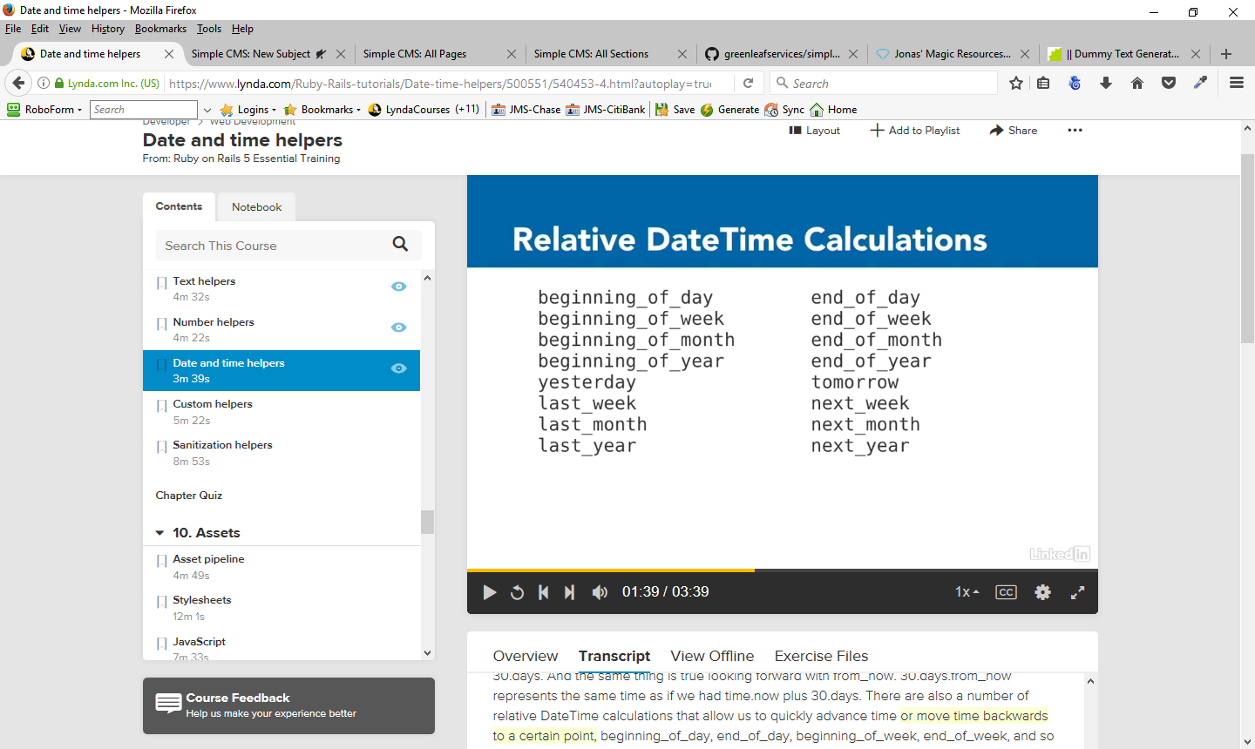
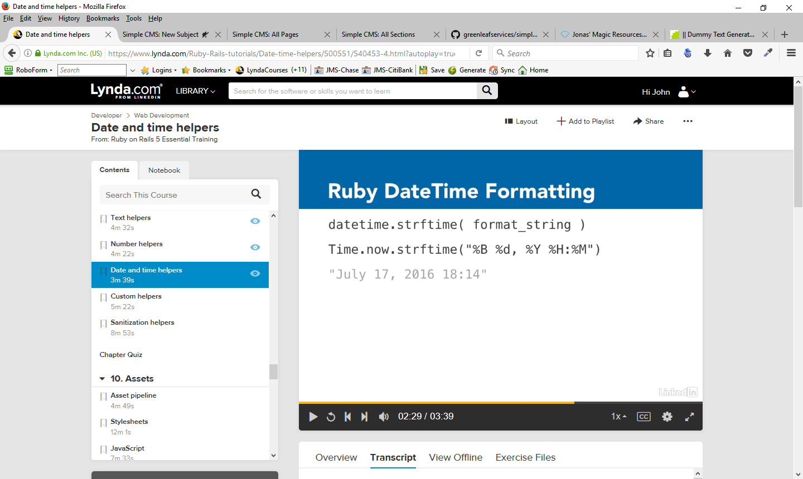
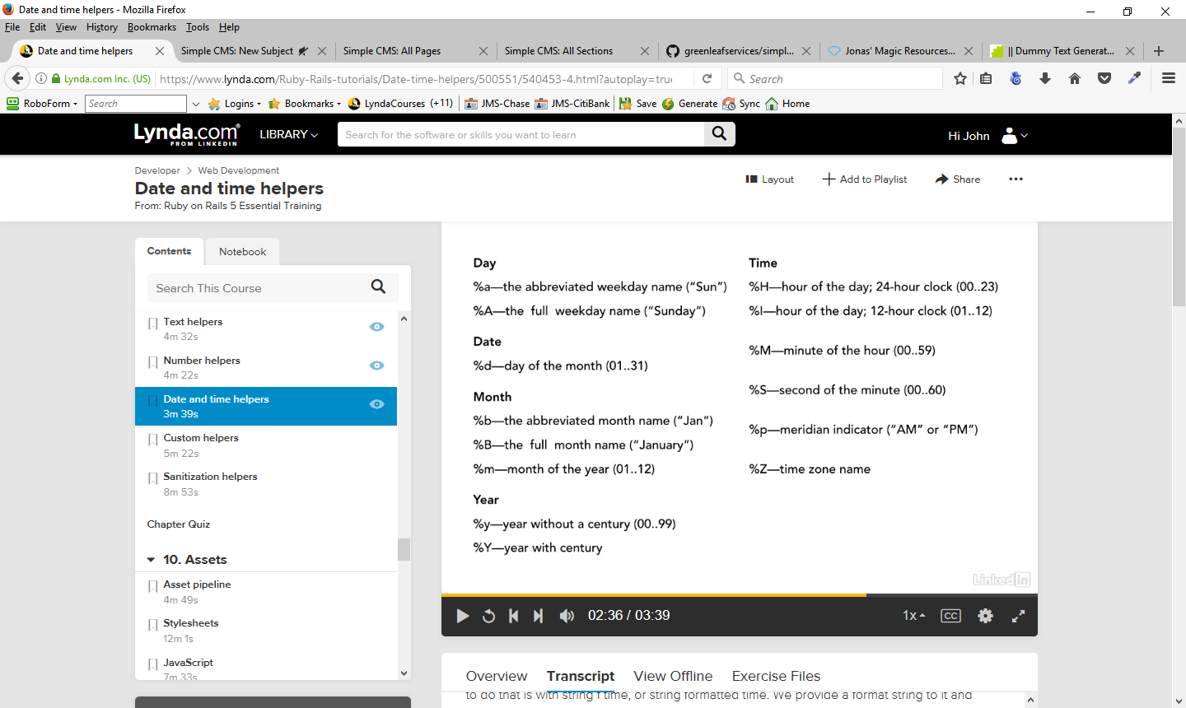
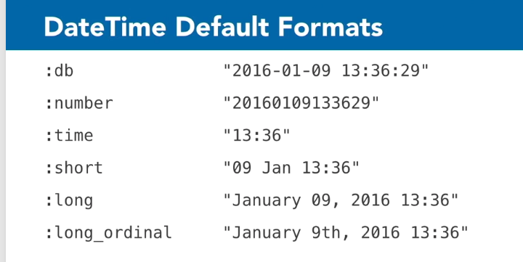
Custom Helpers
But we aren't limited only to the built in helpers. We can add our own custom helpers as well. Helper methods are going to be defined inside Ruby modules. Whenever we generate a controller, Rails generates a placeholder helper file that matches. There's nothing magic about that file it generates. We can write our own helpers too. The only important thing is that the file name and the helper's module name need to match.
Any helper methods that are defined in that file will be available for use in our view templates. Custom Helpers are useful for a couple of different things.
- good place to store code that we're going to need to call often.
- good for putting complex sections of code that we don't want cluttering up our view templates.
- good place to write Ruby code. They are Ruby files. We write Ruby code in them, not HTML. So if you find that you're in your template, and you need to write a large section of Ruby code, it may be easier to do it inside a helper instead of using erb tags every time you need to start and stop outputting HTML.

Helpers are going to be stored inside the app directory and inside the helpers directory. The project has already created a few placeholders for us. Application helper is a place for putting code that is related to our entire application. Then there are specific ones dedicated to each controller, such as Subjects helper.

Example
In application_helper.rb add the following lines:

def status_tag(boolean, options={})
options[:true_text] ||= ''
options[:false_text] ||= ''
if boolean
content_tag(:span, options[:true_text], :class => 'status true')
else
content_tag(:span, options[:false_text], :class => 'status false')
end
end
What this status tag is going to do is it's going to take a boolean and if the boolean is true, it's going to use the content tag helper to generate a content tag for us. This one is going to be a content tag of type 'span'.
The text that it will put in there is whatever text we've told it or it will default to being an empty string and it will give it a class of status true or if it's false, it will give it a class of status false. Then what we'll use is some CSS to be able to style this in whatever way we like. So we can style this boolean to look one way when it's true and another way when it's false.

To use this helper:
In subjects view – in index.html.erb
Change line
<td class="center"><%= subject.visible ? 'Yes' : 'No' %></td>
to
<td class="center"><%= status_tag(subject.visible) %></td> ==> use the status_tag helper and pass in the argument from the db record (subject.visible) = a boolean value

Now, add some CSS in order to use the status tag effectively
in the admin.html.erb add the style information you desire for the following:
span.status, span.status.true, span.status.false

Now, the data for the visible fields will be formatted through the use of the status tag and CSS to look the way we want it to look and we can use the status_tag helper in any of the views we choose when appropriate.
There's no limit to the kinds of things that you can put into your helpers. We have to remember, however, that these are view helpers and their purpose is to assist you in rendering content in the view. The same code is not available in your models or in your controller. These are helpers for our views.

Sanitization Helpers
When we talk about sanitizing content, our primary concern is to prevent cross-site scripting, or XSS for short. In cross-site scripting, a hacker submits a string which is constructed to make our browser do things we don't intend. It lets a hacker use JavaScript to script our site. Which is why it's called cross-site scripting. There are a lot of things that a hacker could do including redirecting users to another webpage, stealing cookie data, or stealing login information.
Examples:
An evil string - a string is a placeholder for any JavaScript. It could be anything that a hacker can dream up. Most likely this string would be submitted via webform or a URL parameter. If at any point we then take that string and we output it to one of our templates, then it's going to insert that JavaScript into our template. And the browser receiving our page will happily execute that JavaScript and do whatever evil action the hacker intended. Erroneous user input - user might inadvertently put in some HTML that we don't want, or which breaks our site layout. Something like a user comment, which contains HTML or CSS, or by adding an extra HTML closing tag. Now, while not as harmful as cross-site scripting, it can still mess up our application for our users. Therefore, we need to consider all user entered data as being unsafe. That means data that comes in from URL parameters, form parameters, cookie data, and even database data.

ERB, which we're using to output our templates, has a method built into it called html_escape(), or just h() for short. This method escapes all of the HTML tags in a string. And it does it by turning every open and close tag symbol into HTML character entities, the ones that start with ampersand. That renders them harmless.

Because this is the Rails default, it will be up to us to tell Rails when we don't want something escaped. It's another example of using a white list approach to application security. We can white list a string by either using the raw helper method, which will output the string one time only without escaping, or by calling html_safe as a method on the string, so that Rails will always consider that string as being marked safe. However, if we modify the string in any way, then Rails sets it back to unsafe again as a precaution.

Practice ==> in the demo controller
New action -
def escape_output
end
Define the route in routes.db - get 'demo/escape_output'
Add a view template to apps/views/demo ==> escape_output.html.erb
Rails Server localhost:3000/demo/escape_output
We will get and output of the strings but notice that the script does not run – Looking at the page source shows us that Rails has escaped the value for a us and has changed the script tag into

&lt;script&gt;alert(&#39;Gotcha!&#39;);&lt;/script&gt;<br />
&lt;strong&gt;Welcome to my site!&lt;/strong&gt;<br />

The &lt; and &gt; around the script tag turns it into just harmless text. It's no longer a script tag, and it no longer executes the JavaScript that's inside.
In older versions of Ruby on Rails, we had to actually put an h in front of these if we wanted it to escape those, but it happens by default now. Instead, we use raw whenever we want to not escape them. We're essentially saying, this one time, don't do any escaping on this string. We want to allow whatever is in here through.

<%= raw evil_string %><br /> ==> this will allow the script to run – one time only
<%= raw good_string %><br />

<<%= evil_string.html_safe %><br /> ==> this will allow the script to run – any time on the page
<%= good_string.html_safe %><br />
Which means don't go marking strings as safe casually. Every html_safe is like dropping your application's XSS defenses. It's fine to do it, but do it wisely.

More helper methods
strip_links - which you can provide a bit of text and it will strip out any links that it finds inside. It won't touch any other HTML, it just removes the links.
strip_tags - strips out all tags, not just the link tags, but any tags that are in the HTML.
sanitize - will remove all HTML and JavaScript from a string, and it does a good job of watching for all the tricks that someone might use to try and sneak some code past us.
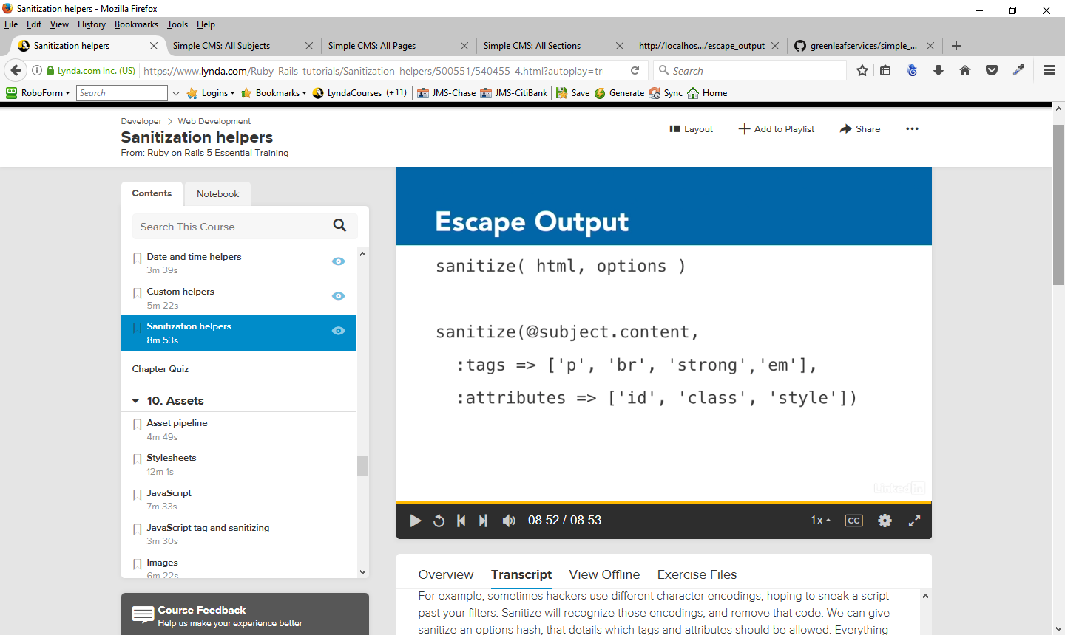
We can give sanitize an options hash, that details which tags and attributes should be allowed. Everything else will be disallowed. In thw example avove, the tags p, br, strong, and em will pass through unchanged. The only attributes that can be used inside those tags, are id, class, and style.

Assets

Asset Pipeline
Ruby on Rails has a feature called Asset Pipeline, which helps to manage the CSS, JavaScript, and images used by your application.
Asset Pipeline offers a few benefits. It concatenates together separate CSS and JavaScript files into single files. That reduces the number of browser requests needed to render a page, and allows caching of these files. It also compresses and minifies the code. It removes white space and comments and compresses them using gzip for web servers that support that.
It precompiles the CSS and the JavaScript. Because it's being precompiled, that also gives us the opportunity to write our CSS and JavaScript using other languages, which can then be compiled into regular old CSS and JavaScript. CoffeeScript is a popular example for writing code for JavaScript, and SAS is a popular way to write CSS. We can even use ERB to have dynamic content in our assets.
It also adds asset fingerprinting. Asset fingerprinting is a clever way to force browsers to keep cached assets up-to-date. What happens is that Asset Pipeline looks at each asset and it develops an MD5 Hash for that asset. That is, it takes the entire contents of the asset and from that distills it down to a single string. And then it pins that string to the end of the file name. And it's called a fingerprint. The reason it does that is because the asset file is gonna be cached by the user's web browser. But whenever something about the file changes, the MD5 Hash will change, and that means that the file name will change. So now the HTML page will be telling the browser to go find a different asset file, because the name is different and that forces the browser to get a fresh copy of the asset.
With the Asset Pipeline, the preferred location for these assets in now in the app/assets directory. Assets can still be placed in the public hierarchy, but if you do, they will be served as static files by the web server exactly as-is.
And you'll give up all of those advantages that we just talked about with using Asset Pipeline.
The way that Asset Pipeline knows which files to concatenate together is through the use of something called the manifest file. The manifest file contains directives telling Asset Pipeline which assets should be included and in what order. Asset Pipeline loads the files in the manifest, processes them if necessary, concatenates them into a single file, and then compresses that file into one. This creates a single smaller stylesheet, which can be cached by a user's browser, and which can contain styles from many parts of the site.
We can separate our CSS up into 20 different files if we want, and they'll all get compressed into one file to serve to the user. So there is an important distinction about the way that Asset Pipeline works with the development versus production. When we are in development, Asset Pipeline skips the concatenation, the compression and the fingerprinting and only does the file processing. If we're using SAS, CoffeeScript or ERB, those will still be interpreted.
But it won't do all the other steps. There are a couple of reasons why that's true. The main one being, that files are changing frequently during development, and so they need reprocessing but it's not worth spinning the extra energy on concatenating, compressing and fingerprinting. When we're in production, though, Asset Pipeline actually skips all of those steps, and it doesn't do any asset processing. Rails assumes that those assets have already been precompiled for it. And that's a necessary step when we're deploying using Asset Pipeline, is we have to actually create those files. We have to take the manifest file, and create those fingerprinted files for it. Those typically reside in public/assets.So how do we do this precompilation? Well, you wanna make sure that your Rails environment is set to production, and then from the root of your Rails application, on the Command line, you could type: bundle exec rails assets colon precompile. Now in truth, most deployment systems used for production will perform this process for you.

Stylesheets
There are several steps to adding stylesheets to your project.
- we need to write the stylesheets.
- we need to add the stylesheet to the manifest file, and add the manifest file to Rail's asset precompile list. That will ensure that Asset Pipeline is able to put together a stylesheet that's ready for serving to the browser.
- we need to go into our HTML and add a stylesheet link tag so that our page will know that that's the stylesheet that should be served up with the page.

Stylesheets should be kept in /app/assets/stylesheets. If for some reason you weren't using Asset Pipeline and you wanted to serve up static stylesheets instead, then you would put them in /public/stylesheets. Stylesheets should end their file names with .scss, but if we're using Sass, then you would end them in .css.scss. It works the same way as the file endings we saw with templates, where we had .html.erb.
Sass is not part of Ruby on Rails, but it is included in Rails and enabled by default. That's because the sass-rails gem is included in our gem file. One really nice feature about Sass is that you don't actually have to use any of the features at all. You can have a Sass stylesheet and use regular old CSS in it. You don't have to learn any additional Sass, you can just have the file be a Sass file.

Rails also gives us a default stylesheet any time we generate a controller. So we have one for subjects, sections, pages, and demo. We don't need all of those separate ones, it's up to us. If we want to keep them grouped by controller, we can.

We create two stylesheets – admin_additions.css.scss and primary.css.scss. Admin Additional Styles is meant to load after that primary file, and it contains additions on top of that, that are suitable for our admin area.

Now that we've written our stylesheets, step two is to add those to the manifest file. By default, we have a manifest file called application.css. In default mode, that file is just a comment file but these lines are special.
*= require_tree .
*= require_self
Even thought these lines that include an equal sign appear to be comments, they are accessed by the rails serve and will be executed. Ther are the directives that tell the manifest file what it should load in. The first is require_tree and then a period after it. That tells it to load in all of the files that are included in the stylesheets directory. The period is the current directory, and tree means require all the files that are there.
At this time, we don't want our application.css to do that. We want it to just load in our primary style. So we remove that by just removing the equal sign in front of it, and that will turn it off so that it's no longer functional. And then the other one is require_self. This is a directive that says that it should load in any styles that we might happen to have in this file so that those get included as well. In general, that's not a great practice. It's much better to put our styles in separate stylesheets and not in the manifest file directly. So we leave that directive in there, but we add another one right before it ==> require primary
We're going to require primary so that application.css is going to require our primary Sass file (primary.css.scss). So that'll get compiled together, and the end result will be a file called application.css. Notice it doesn't have .scss at the end of it, it's just CSS by itself.

Add another manifest file - admin.css. Paste everything from application.css to admin.css. The add the line
*= require admin_additions
Now we have two different manifest files. That will result in two different CSS files, and we can choose which one we want to load in.

So now we have our manifest, the next step is to make sure that Rails knows to precompile these manifest files for us. The way we do that is we go into config. Inside initializers, there's a file called assets.rb, and the part that we care about is where we precompile additional assets. By default, it's already going to compile application.css for us, so we don't need to do anything additionally if we're just using application.css, but we're not. Remember, we created a second manifest file. We need to add the line
Rails.application.config.assets.precompile += %w( admin.css )
Now Asset Pipeline will know to precompile our manifest file, and it know what our manifest file is composed of.

The next step is to tell our HTML about this stylesheet. The way that we declare a stylesheet in HTML is by using a link tag, so we use link href, and then we provide the location of the stylesheet. For Asset Pipeline, those are gonna be stored in /assets/stylesheets, and then the name of the manifest file. application.css, for example.
Instead of using normal HTML process to link the stylesheets, Rails gives us a nice convenient helper that makes that process much easier. We just output stylesheet_link_tag, and then provide the name of the manifest file. You don't need to put .css or anything after it. It knows that that's what it's going to be.

What's great about this helper method is it does more than just write the HTML code you see above. It actually knows whether or not we're in development or in production, and based on our environment, it can adjust the behavior and the path to find our assets. By default, this helper defaults to media => screen for a stylesheet link tag, and we want it to be media => all.
In the layouts/admin.html.erb, remove the style section and add the line
<%= stylesheet_link_tag('admin', :media => 'all') %>

Javascripts
There are four steps to adding a JavaScript file to asset pipeline
- first write your JavaScript file
- then you make sure that it's included in your manifest
- make sure that the manifest is included in the asset precompile list
- go into the HTML and include the JavaScript there so that the page will load.

JavaScript should be kept in app/assets/javascripts. If for some reason you wanted to have static JavaScript that did not use asset pipeline, you could also put that inside public/javascripts. The file name for JavaScripts should always end in dot js unless you're working with CoffeeScript files, which should end in .coffee. CoffeeScript is not part of the Rails framework but it is a technology that's included in Rails by default. And that's because the gems for Coffee-rails and uglifier are included by default.
The JavaScripts managed by asset pipeline are gonna be in app/assets/JavaScripts. Anytime we can create a controller, it creates a placeholder for JavaScript force by default. So we have subjects dot coffee, sections dot coffee and pages dot coffee.

For practice purposes, delete the coffee script fiela nd create a demo.js file.

Notice that we have two other js files already, one is cable dot js, this is a manifest file but it's a manifest file for getting the features together for using action cable. Action cable's a more advanced piece of technology that we're not gonna need as a beginner. This is here as a placeholder to get you started if you decided to use it. So we'll just ignore it for now.
Application dot js, though is the main JavaScript file that's included by default and we can see that it is a manifest file and just like our style sheets, we have directives down at the bottom telling it what it ought to include. We have require jQuery so we're loading in jQuery, we already had it in our gem file which makes sure that it's loaded. Then it loads in a library called jQuery,_ujs. That is unobtrusive JavaScript and it's a library that's needed by Rails. We want to make sure that you have both of these loaded most of the time so that Rails can do its job.
On require tree and require turoblinks, remove the = so they do not load . Then add another directive = require demo. Therefore we are including jQuery, jQuery_ujs and demo.

Add some javascript to demo.js
function jsRoar(name) {
alert('I am ' + name + '. Hear me roar!');
}
Now, make sure the javascript is listed in the precompile list – it is in by default (application.js) so we don't have to do anything extra.

Now, set up the project to actually us the javascript. Rails gives us a helper method to help us output the tag to include the JavaScript file in views/layouts/application.html.erb
<%= javascript_include_tag('application') %>
where 'application' is the name of the manifest. Note that this is include tag, not link tag like we had when we were working with style sheets.
What is great about this helper is it does more than just write the HTML, it knows whether we are in development or production and based on our environment, it adjusts the behavior and the paths to our assets.

In the demo controller, add the line
layout 'application'
which will cause the project to load the layout application.html.erb which will make the demo.js fial avaialbe to the project.

In view/demo/index.html.erb add the line
<%= link_to('Roar', '#', :onclick => "jsRoar('JavaScript'); return true;") %>

In browser, http://localhost:3000/demo/index will show the index page with a link to Roar.

JavaScript Tag and Sanitizing
There's a second JavaScript helper method which is used when we want to put JavaScript directly on a page, that's different than loading in a full file of JavaScript. We use the second helper when we just need to load in a very small javascript bit.
<%= javascript_tag(“alert('Are you sure?');”) %>

There's also a block format that you can use if you need to have slightly more room to write your JavaScript.
<%= javascript_tag do %>
alert('Are you sure?');
<% end %>

The end result is Rails server is going to output content to the browser inside script tags and it's also going to include CDATA tags which is a best practice. Most of the time, were going to put this type of JavaScript at the bottom of your templates so that it always loads after any HTML that's in the template. It still has access to all your loaded JavaScript, and assuming that you've included it in your manifest, it will have access to jQUERY as well.

JavaScript is more interactive than working with Style Sheets. When working with JavaScript, it's not uncommon for us to take user submitted values and to use them inside our JavaScript. For example
<% text = “User submitted text” %>
<%= javascript_tag(“alert('You said: #{text}');”) %>
Here, we're taking some user text that's been submitted, and dropping it into a bit of JavaScript that echoes back what they've said. That's a perfectly innocent way of doing it, but remember that we always have to be suspicious of any user submitted data. We talked about that when we talked about sanitizing for HTML earlier, and cross site scripting. We have to do the same thing with our JavaScript.
Sanitizing JavaScript

Imagine that a hacker crafted some JavaScript that could be anything, it could be stealing cookies, it could be watching keystrokes, it could be sending a user to a different page. So we have to make sure that we sanitize these values before we use them in JavaScript.
Rails gives us a helper method to assist us. It's called escape_javaScript, or the short form, which is just simply j( ).
Change theexample above by adding j(text ) in the { } in the # section

<% text = “User submitted text” %>
<%= javascript_tag(“alert('You said: #{j(text)}');”) %>

So now if a hacker submitted malicious text to us, it would be escaped and it would be rendered harmless. It would just present as a simple text message. It wouldn't be executed as JavaScript. Now note that we would not want to put this escaping around the whole JavaScript string, then the legitimate JavaScript would also be escaped. We just want to put it around the user submitted portion.

Images
Images managed by asset pipeline should be kept inside /app/assets/images. If you weren't using asset pipeline, then you would put them in /public/images. Those locations are similar to what we used for stylesheets and JavaScripts. However, images are different than stylesheets and JavaScripts. A web application has images which are important for the application's interface such as backgrounds, buttons, or icons. But web applications also often use images provided by users.
Those users don't have to just be the general public. They also could be admins who are uploading product images, photographs, or images meant to accompany paragraphs of text. As a general rule of thumb, you should put your core application UI images inside asset pipeline, that is, inside /app/assets/images. But any user-supplied images that are related to content should go in /public/images and not be managed by asset pipeline. If you want your application to allow users to upload additional content images, there are some Ruby gems that can assist you.
The most popular ones are Paperclip and CarrierWave, and you can look up more information about those if you want to use them. Once you put your images in the correct locations, you just need to call them from your templates.

Rails provides the image tag helper to assist you in generating this. You don't need to specify assets. It knows that that's where they're found. You do need to include the file extension for the image though, in this case, .png. You can also specify attributes such as the size of the image or the alt text that ought to be used for the image.
You can specify the size either as a single geometry string or as separate width and height dimensions.
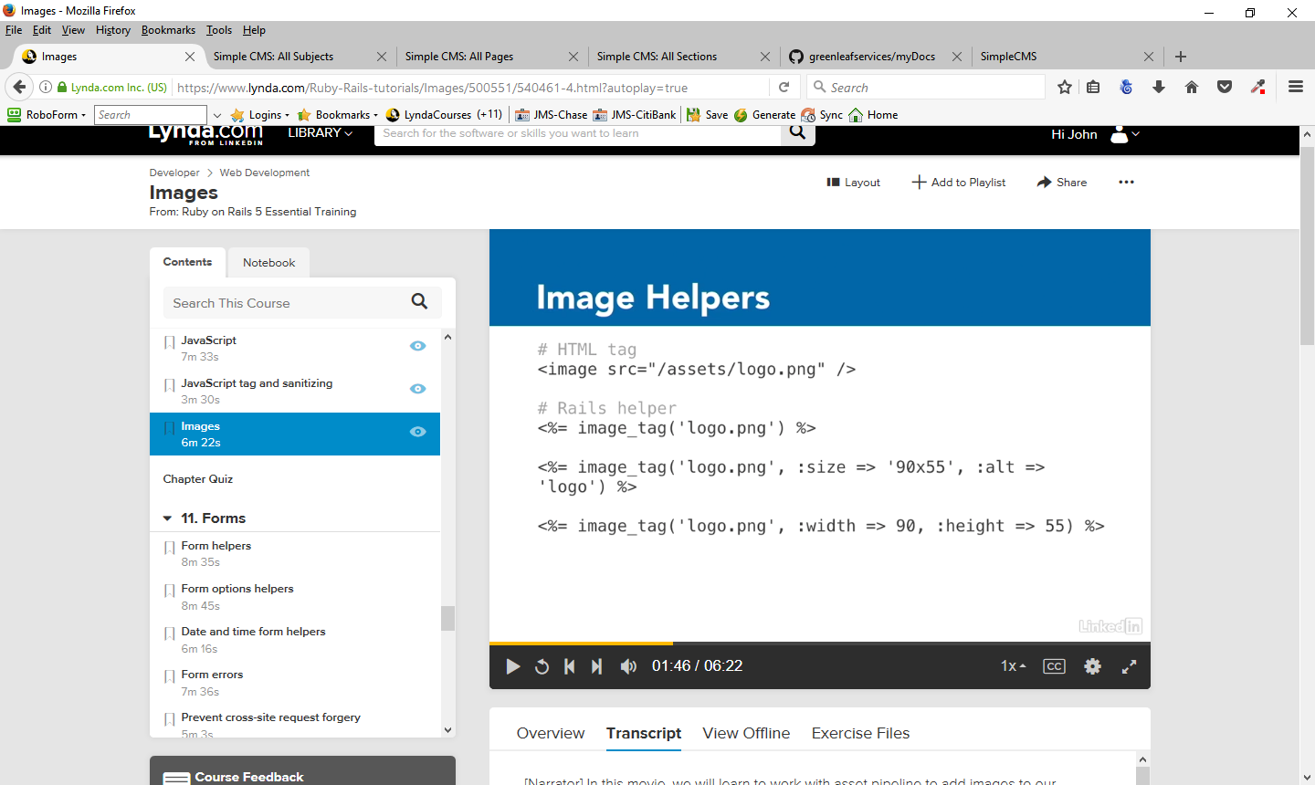
Place an image in the index.html.erb folder , view it in the browser and look at the page source, View Page Source. We'll see that the source for this image is /assets/plus_sign and then it put a fingerprint after it, just like it did for all of our stylesheets and everything else managed by asset pipeline. So if this asset changes in the future, that fingerprint will change and it will force the browser to go get a new version of it.
Now, it says that it's inside assets/plus_sign with fingerprint (no file extension). However, there is not file like this in the project and if we look inside our public directory there's still no assets directly, even when we look directly in there.
What's happening is that asset pipelines is intercepting this request that comes in for assets, and instead of delivering a file from assets, it is going and getting those files out of the assets directory. So even though the request is asking for public assets, instead it's routing it into /app/assets.
That's what happens in development mode. In production, it actually would put those assets into that assets directory for us. But this image tag helper is smart enough to know that we're in our development environment right now and that those assets are not there.

There's another common way that you use images inside your project - from your CSS files.
In primary.css.scss - footer – add a background color on that footer by adding an image there - gradient image – footer_gradient.png.
Also. To use that as our background. In normal CSS would be we would use url and then we'd provide the path /assets/footer_gradient.png.
background: $light_brown url('/assets/footer_gradient.png') repeat-y 0 0;
Instead, we write
background: $light_brown image-url('footer_gradient.png')
What that does is it allows it to find this asset in our assets directory. So we don't have to specify assets anymore. And it's able to know whether or not we're in our development environment or our production environment, just like we saw with that other helper. It's essentially the same kind of helper that we had.

